Appendix 1 to ToR

Information Memorandum
DARCHI HPP (17.5 MW)

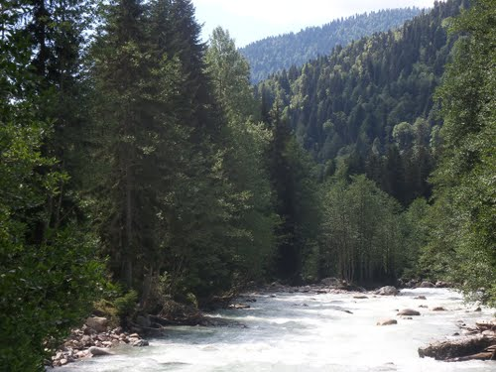

Georgia

November 2020

Definition of Abbreviations

EIA | Environmental impact assessment
ETL | Electricity transmission line
GEL | Georgian Lari
GoG | Government of Georgia
GW | Gigawatt
GWh | Gigawatt-hours
ha | Hectare
HPP | Hydropower Plant
kg/s | Kilograms per second
kV | Kilovolt
kW | Kilowatt (a measure of power)
kWh | Kilowatt-hour (a measure of energy)
m3/s | Cubic meters per second
masl | Meters above sea level
MoE | Ministry of Economy and Sustainable Development of Georgia
MEP | Ministry of Environmental Protection and Agriculture of Georgia
MFL | Maximum flood level
MW | Megawatts
MWh | Megawatt-hours
NFL | Normal flood level
SEE | State ecological examination
SS | Substation
VAT | Value added tax

Table of Contents
1. EXECUTIVE SUMMARY 6
2. PROJECT DESCRIPTION 6
2.1. Project location 6
2.2. Project significant data 8
2.3. Hydrological regime 13
2.4. Flooding and flood risks 14
2.5. Project design 15
2.6. Headwork 15
2.7. Concrete, low pressure, gravitational, spillway dam 16
2.7.1. Flushing sluice 17
2.7.2. Apron 19
2.7.3. Intake 19
2.7.4. Transitional zone from intake to sediment basin 19
2.7.5. Sediment basin 20
2.7.6. Bank protection structure 21
2.7.7. Fish way 21
2.7.8. Headrace pipe 22
2.7.9. Low-pressure tunnel 23
2.7.10. Surge Tank 26
2.7.11. Safety Valve 27
2.7.12. Penstock 28
2.7.13. Powerhouse 30
2.7.14. Tail water pipe 32
2.8. Construction 34
2.8.1. Overview of the Construction Approach 34
2.8.2. Construction Camps 34
2.8.3. Access Roads 35
2.8.3.1. New Roads 35
2.8.3.2. Road rehabilitation 37
2.8.4. Damping areas 38
2.8.5. Headwork’s construction organization 40
2.8.6. Construction of diversion pipeline 41
2.8.7. Construction of penstock 41
2.8.8. Construction of tunnel and surge tank 42
2.8.9. Water supply, wastewater and waste 44
2.9. Construction schedule / interface management 45
2.9.1. Health and Safety (H&S) 47
3. ENVIRONMENTAL AND SOCIAL (E&S) ISSUES 57
3.1. Overview of E&S impacts 57
3.1.1. Introduction 57
3.1.2. Biodiversity 58
3.1.3. Social Context 65
3.1.4. Cumulative Impact Assessment 66
3.1.5. Positive Impacts 69
3.2. ESMP Summary 70
4. ROJECT PARTIES 71
4.1. SPV 71
4.2. Project organization and contractors 71

List of Tables
Table 1: Project significant data
Table 2. Hydrology significant data
Table 3. Average annual discharge values at section of the headwork
Table 4. Permits and licenses to be obtained for construction of the Project
Table 5. Work distribution among Subcontractors
List of Figures
Figure 1. Project location Map
Figure 2. The scheme of the power plant
Figure 3. Darchi-Ormeleti discharges during different provisions of water, m3/s
Figure 4. Headwork plan
Figure 5. Longitudinal section of the dam
Figure 6. Plan view of sediment basin
Figure 7. Longitudinal section of the fish pass
Figure 8. Longitudinal profile of the tunnel
Figure 9. Type of tunnel finishing
Figure 10. Plan of the entrance portal
Figure 11. Plan of the penstock protection valve building foundation
Figure 12. Longitudinal profile of the penstock
Figure 13. Cross section of the powerhouse building
Figure 14. Construction camp plan
Figure 15. New roads plan
Figure 16. Locations of spoil grounds
Figure 17. Tunnel drilling-blasting method cycle
Figure 18. Baseline Timeline Gantt chart
Figure 19. Project contractors

EXECUTIVE SUMMARY
The site of the proposed Darchi HPP is on the Darchi-Ormeleti River upstream from its confluence with the Nenskra River. The Implementation Agreement signed on February 17, 2014 with Government of Georgia grants Darchi LLC exclusive right to develop and construct this greenfield hydropower project.
The scenario for the development of this HPP considers construction of the proposed Khudoni Dam and Reservoir Project on the Enguri River. That potential future project would have a maximum reservoir elevation of 723.5 masl (this elevation in Baltic coordinates system represents 700 masl), considering this the planned tail water elevation of the project will be only 724.1 masl, the gross head - about 224.35m. Designed installed capacity of the plant will be about 16.9 MW.
The river flows in Upper Svaneti are very seasonal. Discharges are low during winter months when most precipitation falls as snow, and are high during spring and summer when melt-water and rain runoff are combined.
The project layout includes: a low diversion dam with sluiceways, a de-silting facility, headrace pipe, tunnel water conductor, surge tank, penstock, powerhouse, tailrace pipe, energy extinguishing well, substation, and a transmission line.

PROJECT DESCRIPTION

Project location
The Darchi-Ormeleti Project area is located in Mestia Municipality, which is part of the Samegrelo-Upper Svaneti Region Administrative Unit. The Mestia Municipality occupies the upper part of the Enguri River watershed and is located between the elevations of 500 m and 5,070 m above sea level. Total area of Mestia Municipality is approximately 3,044.5 km². The population for the whole district is about 14,248, giving a population density of approximately 5 people per km². 99.4% of the residents are Georgians.
The economy is mainly based on subsistence agriculture. Animal husbandry, grain and hay crop production, vegetable (mainly potato) production, and forestry are developed in the region. The Mestia District is also well-known for its mineral resources.
Mestia is popular tourist spots in the country, due to rich natural, cultural and historical assets. Extensive tourist developments are under construction or planned for the area. These include a world-class skiing and winter sports destination resort.
The Darchi-Ormeleti Project area lies near the Chuberi community. The nearest settlement to the project site is the village Lukhi, which are located at an elevation of 670 m above sea level and is 75 km far from Mestia and 73 km far from Zugdidi.
Figure 1. Project location map
Darchi HPP area
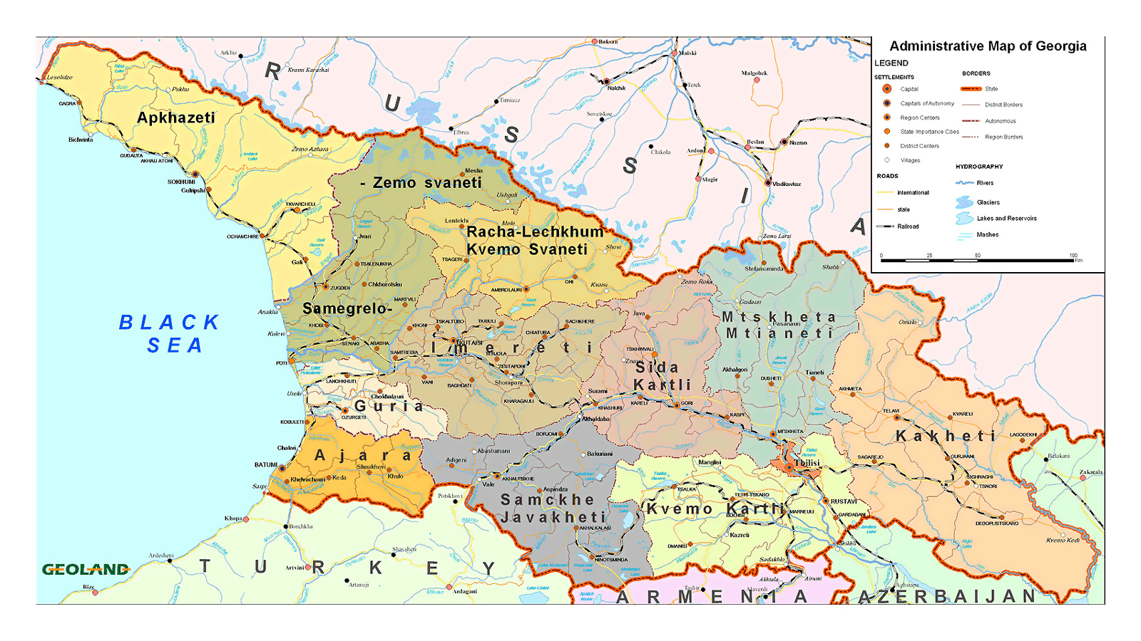

Project significant data
The most important data of the project is provided below:
Table 1: Project significant data
 | General
 | Project name | Darchi Hydropower Project
 | Project location (political) | Mestia District of northern Georgia’s  Samegrelo - Zemo Svaneti Region
 | Nearest town or city | Lukhi and Tobari villages
 | River name | Darchi-Ormeleti River
 | Watershed name | Nenskra river
 | Drainage area at diversion | 140 km²
 | Hydrological Data
 | Mean river flow at intake | 7.31 m³/s
 | Facility design discharge (m³/s) | 9.6 m³/s
 | Design flood (100 yr return period) | 310 m³/s
Sanitary or environmental bypass flow (assumed) |  | 10% of mean annual flow
Diversion Facility
 | Maximum flood level | 957.00 masl
 | Normal flood level | 955.50 masl
 | Building tooth elevation:  Upstream / downstream | 950.00 / 946.00 masl
 | Maximum height of the building | 9.50 m
 | Flooding area during MFL | 8 346 m²
 | Flooding area during NFL | 5 147 m²
 | Reservoir volume during MFL | 27 830 m³
 | Reservoir volume during NFL | 12 360 m³
Spillway part of the Dam
 | Maximum calculated water discharge | 128 m³/sec
 | Elevation of the spillway bow | 955.50 masl
 | Deepening of the tooth from the upper bay | 2 m
 | Deepening of the tooth from the lower side | 6 m
 | Spillway length | 22 m
 | Spillway height (from the upper stream side) | 3.5 m
 | Length of dissipation basin | 9 m
 | Depth of dissipation basin | 0.8 m
Flushing Sluice
 | Maximum calculated water discharge | 182 m³/sec
 | Floatbet elevation | 952.50 masl
 | Deepening of the tooth from the upper bay | 2 m
 | Deepening of the tooth from the lower side | 6 m
 | Number of flushing rolling gates | 2 pcs
 | Dimensions of flushing rolling gates | 6X3.5 m
 | Length of dissipation basin | 13 m
 | Depth of dissipation basin | 1.5 m
Apron
 | Apron slab surface elevation | 952.00 masl
 | Length | 27 m
 | Width | 6 m
 | Thickness | 0.5 m
Intake
 | Intake calculated water discharge | 9.60 m³/sec
 | Intake orifices threshold | 954.00 masl
 | Number intake orifices | 2 pcs
 | Dimensions of orifices flat gates | 2X2 m
 | Dimensions of the trash racks | 2X2 m
 | Length of transitional Zone | 20 m
 | Width of transitional Zone | 5 m
 | Length of automatic spillway | 6 m
 | Spillway threshold elevation | 956.00 masl
 | Diameter of flushing orifices | 1.4 m
 | flushing orifices threshold elevation | 952.50 m
 | Dimension of the gates of the flushing orifices | 1.5X1.5 m
 | Fishway
 | Calculated water discharge | 0.73 m³/sec
 | Number of ladders | 8 pcs
 | Width of the ladder | 1.5 m
 | Length of the ladder | 1.55 m
 | Ladders total length | 14.45 m
 | Top elevation of the inlet orifice | 955.05 masl
 | Dimension of the orifices | 0.3X0.2 m
 | Sediment Basin
 | Calculated water discharge | 9.60 m³/sec
 | Number of chambers | 1 pcs
 | Flushing regime | periodical
 | Length | 99 m
 | Width of the chamber | 8 m
 | Longitudinal slope of the bottom | 0.005
 | Average speed of water movement | 0.4 m/sec
 | Height of the walls | 4.3 m
 | Depth of tooth to right walls | 3.2 m
 | Average depth of tooth | 3 m
 | Depth of sediment accumulation | 1 m
 | Diameter of sediment flushing orifice | 1.4 m
 | Thresholds elevation of sediment flushing orifice | 949.80 masl
 | Dimensions of the flat gates for sediment flushing orifice | 1.6X1.6 m
 | spillway threshold elevation | 953.00 masl
 | Spillway length | 6 m
 | Design water level | 952.35 masl
Derivation-pressurized system
Diversion pipe
Pipe length |  | 1179 m
Pipe inner diameter |  | 2.0-2.2 m
Pipe thickness |  | 12 mm
 | Power Tunnel
 | Tunnel length (inc. pipe up until Surge tank) | 1212 m
 | Tunnel diameter (horseshoe shape) | 3.2 m
 | Bottom elevation of the tunnel inlet portal | 942.5 masl
 | Bottom elevation of the tunnel outlet portal | 940.1 masl
 | Tunnel laying method | Drill and blast
 | Surge Tank (Tank)
 | Internal diameter of the Surge Tank | 5.0 m
 | Maximum water level in the Surge Tank | 960.53 masl
 | Height of the Surge Tank | 17.42 m
 | Pressure Penstock
 | The length of the pipeline from the tunnel to the HPP building | 443.1 m
 | Pipe inner diameter | 1 800 mm
 | Pipe thickness | 14.5 mm
 | Powerhouse
 | Type | Above-ground
 | Installed capacity, at generator terminals | 18.56 MW
 | Number of units | 2
 | Type of units | Vertical Pelton
 | Net capacity at high voltage transformer terminals | 17.85 MW
 | Rated speed | 430 rpm
 | Generator voltage | 6.3 kV
 | Rated generator capacity | 2x9.79 MVA at 0.85 Power Factor
 | Size of powerhouse | 10.64 m x 23.34 m x 15.15 m high
 | HPP building landmark elevation | 732.25
 | Turbine axis elevation | 727.50
 | Tailrace
 | Length | 100 m
 | Type | Pipe
 | Transmission line
 | Interconnection voltage | 110 kV (possible 35KV)
 | Distance to interconnection, Nenskra line (km) | 0.4 km (12 km in case of 35 KV)
 | Power & Energy
 | Gross head | 224.35 m
 | Total head loss at rated discharge | 14.81 m
 | Net head at rated discharge | 209.54 m
 | Estimated average annual generation (50% provision) | 90.5 GWh
 | Nominal installed capacity | 17.5 MW
 | Annual plant factor | 59.0 %

Figure 2. The scheme of the power plant
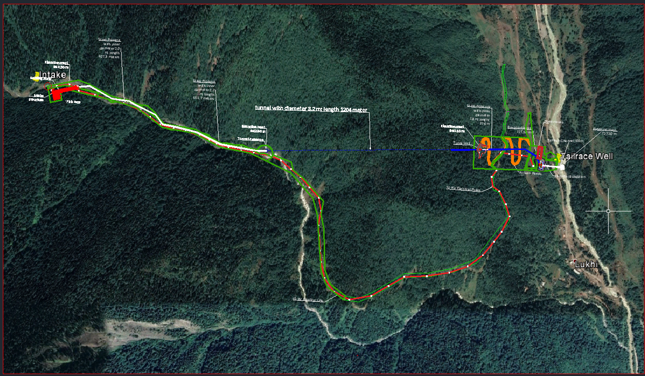

Hydrological regime
The river of Darchi-Ormeleti originates from the eastern slopes of Kodori mountain range, at the height of 2660 m above a small glacier on the eastern slope and joins Nenskra River from the right side at the village of Lukhi.
A length of the river till the headwork section of the project hydropower station (1000 masl) is 21,2 km, general fall 1660 m, average incline 78%, area of the catchment basin 140 km², mean height of the basin – 1945 m. On this section, a single main tributary – Kharikhantishi River – joins the river with a length of 7,6 km.
A shape of the river is asymmetric due to the abundant left tributaries. The river basin, which is directed from the west to the east, is bordered from the west and from the north by Kodori Mountain Range, while from the south – by Khojali Mountain Range. The basin’s watershed marks range from 1785 m to 3313 m.
The river is fed by snow, rain and ground waters. Its water regimen is characterized by floods in spring and summer, high waters in summer and autumn and relatively stable low waters in winter times. The ice phenomena on the river are observed as ice buildups on the banks from November to the end of February. The river is not in use for economic purposes.
Table 2. Hydrology Significant Data
Drainage area at gauge | 140 km²
Maximum plant discharge | 9.6 m³/s
Minimum plant discharge | As low as 0.48 m³/s
Annual average flow (m³/s) | 7.21 m³/s
Maximum water discharge | 310 m³/s
Minimum water discharge | 1.87 m³/s
Assumed river discharge reserved for environmental/sanitary means | 10% of average annual discharge

The values average annual discharges of Darchi-Ormeleti River are determined using the method described in the monograph - The Georgian Water Balance. According to the abovementioned method, a height of runoff layer of the studied river basin’s average height is determined based on the curve of average heights of the basin constructed for the region of the studied river basin location versus the heights of runoff layer, which is in this case 1648 mm.

Table 3. Average annual discharge values at section of the headwork
km² | m | mm | m³/sec |  |  | Provision %
 |  |  |  |  |  | 10 | 25 | 50 | 75 | 80 | 85 | 90
140 | 1945 | 1648 | 7.31 | 0.20 | 0.40 | 9.21 | 8.26 | 7.21 | 6.27 | 6.07 | 5.79 | 5.51

Within-year distribution of the design provision of Darchi-Ormeleti River (10%, 50% and 90%) was made based on the within-year distribution of the hydrologically unstudied rivers specified in the abovementioned hydrology handbook; with its percentage distribution by months is determined based on the average basin heights. The value of sanitary discharge of the river is equal to 10% of the average perennial discharge of river in the water intake section.
Figure 3. Darchi-Ormeleti discharges during different provisions of water, m³/s

Flooding and flood risks
Flooding occurs frequently in the project watershed and in the project vicinity. Steep slopes, deep gorges, significant areas of exposed rock and impervious surfaces, snowmelt runoff enhanced by warm temperatures and intense precipitation all contribute to major flooding risk for the project and the local environment.
These flood flows were adjusted to the diversion location using a simple drainage basin area ratio. Because of the very short period of record, the probabilities of only relatively common flood events should be considered reliable. The divergence of the green 5 and 95 percent confidence limit lines shows the greater uncertainties in floods larger than about the 10-year event. Further flood hydrology studies should be conducted during the design phase of development to improve the understanding of rarer flood events.

Project design
Construction of Darchi HPP is planned in Khaishi community of Samegrelo-Zemo Svaneti region, Mestia municipality. According to the preliminary project the HPP will be arranged in the Darchi-Ormeleti River Gorge, at 958.5-724.5 m above sea level. The HPP includes the following main structures:
- Concrete low pressure, gravitational, spillway dam;
- Flushing sluice with two gates;
- Fish way;
- Water intake unit;
- Sediment basin;
- Headrace pipe from sediment basin to the tunnel;
- Tunnel with surge tank;
- Penstock from tunnel exit to powerhouse;
- Powerhouse (with two Pelton turbines) with auxiliary structures;
- Tailrace pipe;
- Transformer substation and power transmission line.

The main parameters of the HPP according to the project are presented in Table 1. In addition, temporary construction infrastructure will be arranged at the construction stage in the vicinity of the design hydraulic structures. Areas in the gorge will be allocated for the disposal of waste rock generated during tunneling and earthworks. New roads will be arranged to access individual infrastructural facilities.

Headwork
The headwork of Darchi HPP will be arranged on Darchi-Ormeleti River, at an altitude of 951÷953 m (riverbed elevation at the dam site).
According to the design data, the headwork shall intake 9.60 m³/s flow from Darchi-Ormeleti River. According to the hydrological data of the river, this flow will be ensured during 4 months (April-July), which is in line with the currently applicable practice of defining the design flow of the HPPs under construction and it shall be considered acceptable.
According to the finally selected scheme, the headwork includes the following structures:
- Concrete, low pressure, gravitational, spillway dam;
- Flushing sluice with two gates;
- Apron;
- Intake;
- Transitional zone from intake to sediment basin;
- Sediment basin;
- Fish way.

Below is a description of each component of the headwork. The general plan of headwork is shown in Figure 4.

Concrete, low pressure, gravitational, spillway dam
The dam will be located on the right bank of the river. The total length of the dam is 24.0 m, and the width (including dissipation basin) - 14.45 m. The dam crest is at 955.50 masl. Its height above the average elevation of riverbed (952.00 masl) is 3.5 m. The total height from the downstream toe of the dam (946.00 masl) is 9.5 m. The depth of the upstream toe of the dam is 2 m, and the depth of the downstream toe of the dam is 6 m. The depth of the downstream toe of the dam is determined by engineering-geological conditions and depth of wash-out.
Junction of the dam with the left bank of the river is made through the reinforced concrete wall, the crest level of which corresponds to the upstream and downstream maximum water levels and is at 958.50 and 955.50 masl correspondingly, and the levels of toes of the dam - at 950.00 and 948.00 masl correspondingly.
The dam is a vacuum-free spillway with a permeability of 128 m³/s. Dissipation basin will be arranged downstream the parameters of which are determined by a hydraulic calculation. The length of dissipation basin is 9.0 m, and the width – 0.8 m. Energy dissipation basin is then followed by a stone spillway apron with a thickness of 1.5 m, length - 12 m, which ensures protection of the downstream of the dam from wash-out. The design diameter of the stone of the spillway apron is ≥70 cm.

Figure 4. Headwork plan
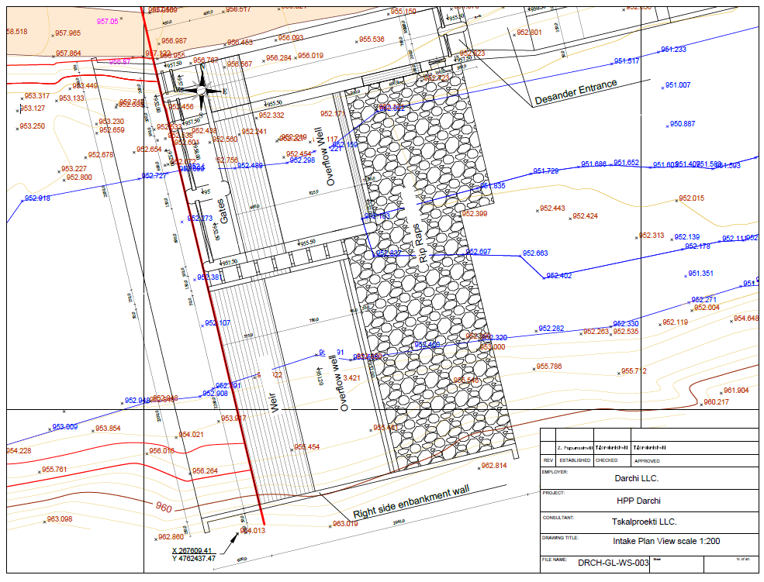

Flushing sluice
The flushing sluice will be located on the left bank of the river near the intake. It is envisaged to arrange flushing sluice with two gates (each 6.0 m wide). Flushing sulice apron elevation within the flushing gate installation zone is 952.50 masl. Flushing gate threshold is 0.5 m above the upstream apron surface elevation. 6X3.5 m surface rolling gates are installed in the flushing sluice. The gates will be equipped with electric drives with a power of N = 3 kW.
The gate permeability, taking into account the maximum water level (957.00 masl) is 182 m³/s. Consequently, the maximum water flow released through spillway and gates is 310 m³/s.
Energy dissipation basin will be arranged downstream, the parameters of which are determined by the hydraulic calculation. The length of the dissipation basin is 13.0 m, and the depth – 1.5 m. Energy dissipation basin is then followed by a stone spillway apron with a thickness of 1.5 m, length - 12 m, which ensures protection of the downstream of the dam from wash-out. The design diameter of the stone of the spillway apron is ≥70 cm. The depth of the upstream toe of the dam is 2 m, and the depth of the downstream toe of the dam is 6 m.
Figure 5. Longitudinal section of the dam
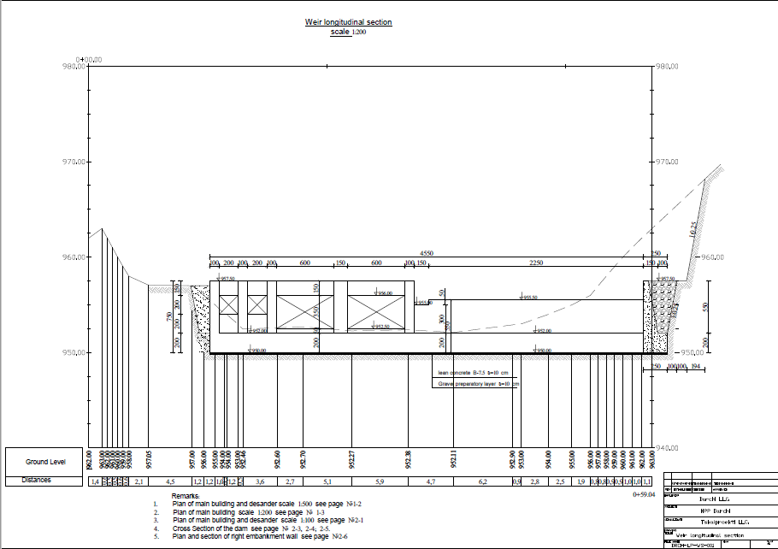
Service platform with a width of 1.20 m will be arranged on the flushing sluice at 960.00 masl elevation, which is connected to the service platform of intake with a ladder at 957.50 masl elevation. A metal railing will be arranged along the entire length of the platform.
The spillway dam and flushing sluice will be made of reinforced concrete of the B-30 W-8, F-150 mark, except for a surface layer of up to 50 cm thick that shall be made of a special concrete of B-35 mark made of high-density inert materials. Other parts of the headwork structures (lateral wall, intake, sediment basin) shall be made of concrete of B-30 W-8, F-150 mark.
Permeability of the spillway dam and flushing sluice is calculated separately. Calculation results show that the dam stability condition is acceptable. In addition, in order to reduce the impact of the filter flow on the dam and to increase the reliability of the dam, an additional 6 m long apron is installed upstream.

Apron
At the dam site, in view of the filtration characteristics of the grounds in the riverbed, in order to increase the water filtration flow and consequently to reduce the filtering gradients, the apron will be arranged upstream of the dam in the form of a monolithic concrete slab. 6 m wide apron will be arranged runs along the entire pressure front and is 47 m long, 0.5 m thick.
The purpose of the apron is to increase the length of the underground contour of the dam by correspondingly reducing the filtration flow length and to reduce the pressure gradients at the base of the dam. In the practice of hydraulic construction, both rigid and flexible apron structures are used. Rigid apron structures are predominantly made of monolithic concrete, and flexible apron structures often represent a clay screen with a very low filtering ratio, the surface of which must be protected against wash-out with concrete slabs or stone paving.

Intake
Intake will be arranged on the left bank of the river, near the flushing sluice. Consequently, the bottom of the intake orifices will be1.5 m higher than the flushing orifice apron. This should reduce the occurrence of large sediment in the intake. The threshold in the plan is curvilineal (R=8.31 m, α=71⁰24’ K=10.35 m, T=5.97 m). It will be attached to the left bank wall and to the left pier of the flushing sluice. Such a threshold will help to direct bottom sediments towards the flushing sluice.
The number and dimensions of intake orifices were calculated according to the estimated water flow of 9.60 m³/s and the permissible velocity at the inlet of the intake (1.50 m/s). The dimensions of the intake orifices are 2X2m, in which flat gates will be installed and a coarse trash rack of the same dimensions will be installed in front of the gates. The gates will be equipped with electric drives with a power of N = 1.7 kW. A service platform will be arranged on the intake at an elevation of 957.50 masl from which gates can be operated.

Transitional zone from intake to sediment basin
After the intake orifices, the transitional zone from intake to sediment basin begins, which is a 20 m long and 5 m wide linear channel with a rectangular section. The inclined bottom of the channel is at 953.50 m elevation, and the inlet of the sediment basin is at 952.50 masl elevation. An automatic spillway will be arranged in the right wall to automatically return the excess water from the intake orifices to the river in case of a delay in closing the gates due to a sharp increase of water level in the river. The length of the automatic spillway is 6,0 m. The height of the lateral walls of the transitional zone allows forced flooding of up to 957.00 masl elevation. Consequently, an automatic spillway can release 9.6 m³/s flow.
Flushing orifices for bottom sediments in the intake will be arranged at the end of the transitional zone of intake, near the sediment basin, in the right wall, the dimensions of which shall be set taking into account the required pressure and flushing velocity (not less than 4 m/s). At the entrance of orifices, 1.5X1.5 m deep gate will be arranged, which will be equipped with an electric drive with power of N = 1.7 kW. The sediment flows on the downstream apron through a flushing steel pipe D=1400 mm, δ=10 mm, L=1.6 m.

Sediment basin
In order to avoid suspended particles in the turbines, the sediment basin will be arranged on the left bank terrace of the river. It is planned to arrange a periodic hydraulic single-chamber flushing sediment basin. The design flow is 9.6 m³/s. The sedimentation basin is calculated for the deposition of particles of 0.2 mm and more (hydraulic thickness = 1.45 cm/s).
The sediment basin chamber has a rectangular cross-section, the longitudinal slope of the bottom is 0.005, the transverse slope in the direction of the center of sediment basin – 0.06. The sediment basin will be arranged with monolithic B-30 mark reinforced concrete. The height of the sediment basin is 4.3 m. The base thickness is 100 cm in the central part. The length of the sediment basin is divided into 14.0 m long blocks. A pedestrian bridge will be arranged at the end of each block. The sediment basin is connected to the inlet of the penstock.
At the inlet of the penstock, the spillway threshold is arranged the height of which is 3.00 m . The flushing pipe will be arranged in front of the threshold with D=1400 mm, δ=10 mm, length - 2 m, which forms a 90⁰ angle at the axis of the sediment basin. A deep flat gate 1.6x1.6 m will be arranged at the inlet of the flushing pipe. The gate will be equipped with an electric drive power of N = 1.7 kW. Width of the inlet is 8 m, the case elevation - 958.00 masl, height of the walls – 5m. The crest level of the wall - 953.00 masl, design water level - 952.35 masl. Length of the penstock inlet including spillway is 7m.
At the front wall of the headwork, which is a massive reinforced concrete structure, an inlet orifice of steel penstock will be arranged (D=2000 mm, δ=12 mm). A fine trash rack 2x2m will be arranged in the orifice.
After the front wall of the headwork, the penstock vertically joins the air pipe 500x6 mm. In the right wall, at the penstock threshold, it is planned to arrange the flushing pipe D=1400 mm, δ=10 mm, length - 2 m. A deep flat gate 1.6x1.6 m will be arranged at the inlet of the flushing pipe. The gate will be equipped with an electric drive power of N = 1.7 kW.
An automatic spillway will be arranged in the right wall to automatically return the excess water from the sediment basin to the river in case of a delay in closing the gates due to a sharp increase of water level in the river. The length of the automatic spillway is 6,0 m, the crest elevation - 954.00 masl. An automatic spillway can release 4.0 m³/s flow in case of maximum water level (954.50 m). The inlet of the penstock is covered with a monolithic reinforced concrete slab (30 cm thick).
Figure 6. Plan view of sediment basin
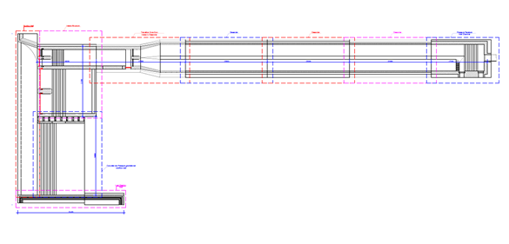

Bank protection structure
In order to protect the right bank of the river from the erosion at the headwork, it is planned to arrange a retaining wall. On the left bank, there will be an infrastructure of the headwork and sediment basin that will protect the bank and therefore, there is no need to arrange a retaining wall.
According to the project, it is planned to arrange a reinforced concrete structure with a length of 32 m and a 5 m high wall. The base of the wall will be 2m high and placed in rocks.

Fish way
The headwork will include a special fish way in order to ensure fish migration from downstream to the upstream direction. The fish way will be located on the left side of the dam, between the spillway and the gates.
The project envisages arranging a fish ladder. Its length will be 14.45 m. The elevation of the inlet orifice is 955.05 masl, which is 45 cm lower than the spillway dam crest level. Thus, the flow of water into the fish way is guaranteed and calculated on an environmental flow. The threshold of the exit orifice (from downstream) of fish way is at 952.00 masl elevation. 8 ladders each 45 cm high will be arranged along the entire length of the fish way. The threshold of the ladder is 45 cm above the level of the bottom of the ladder, providing the minimum required depth of water at the fishway ladders. The width of the ladders is 1.5 m, length - 1.55 m. The bottom orifices 30X20 cm will be arranged in the ladders, making it easier for fish to move.
When designing fish way, the recommendations in the relevant technical literature are taken into account. The water flow velocity at thresholds of the ladders does not exceed 1.2 m/s, which is less than the speed limit (1.5 - 2 m/s) for fish species such as trout. The dimension of the sections of the ladder corresponds to the recommended dimensions (width of not less than 1.5 m, length - not less than 1.5 m, water depth - 0.6 m, orifices - 0.3X.2 m).

Figure 7. Longitudinal section of the fish pass
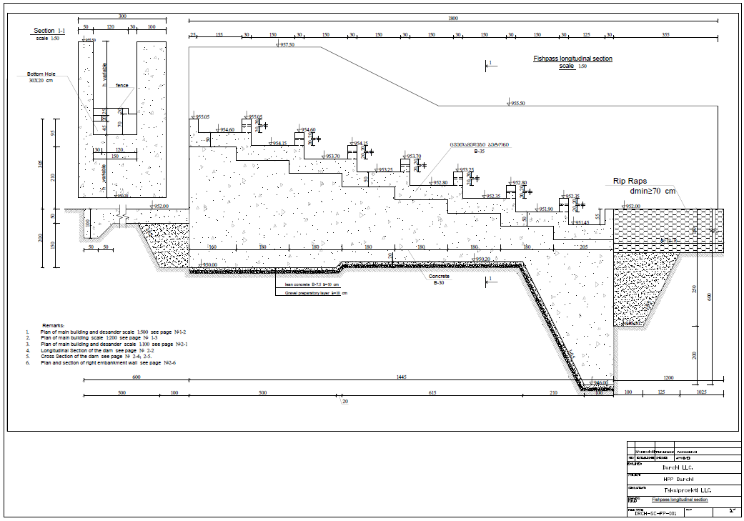

Headrace pipe
The penstock starts at the end of sedimentation basin. The penstock starts at the end of the sediment basin. The penstock inlet threshold is at 948.0 masl elevation that ensures the required pressure regime at the design water level at the top of the penstock (952.35) with consideration of the necessary deepening. Deepening at the top of the penstock from water level (S) is calculated with formula S=2.3V√(hb/2g). Where, V=3.06 m/s is the speed of water entering the penstock; h_{b}=2.0 m – height of the orifice (in our case pipe diameter), g=9.81 – acceleration of free drop. Accordingly, S=2.3x3.06x√(2/19.62)=2.25 m. Considering the loss of pressure on the grid (hg=0.1 m), S=2.35 m. Consequently, the design water level at the top of the pipeline entrance will be 948.0+S+ h_{b}=952.35.
The penstock will be made of steel pipe (inner diameter 2200 – 2000 mm, wall thickness 12 mm). The penstock route runs along the left bank of the river on the slope side. The length of the penstock is 1179 m and ends at the entrance portal of pressure tunnel. Part of the penstock 627.3 m is 2200 mm in diameter, the rest 551.7 diameter will be 2000 mm. The longitudinal slope of the penstock at pk 0+00–pk 0+18.3 section is 0.049, pk 0+18.3 – pk 0+65.3 – 0.00213, pk 0+65.3 – pk 2+12.2 – 0.00068, pk 2+12.2 – pk 3+34 – 0.025, pk 3+34 – pk 4+80 – 0.068 and from pk 4+80 till the end of the penstock – 0.000866. There are 45 horizontal angles on the penstock route (α=2⁰ ÷ 43⁰). Design flow of the penstock is 9.6 m³/s, at which average speed of water in penstock is 3.06 m/s.
The penstock, along the entire length, will be arranged in tranche, the bottom of which is 2.5 m wide, and the height is variable. The tranche slopes are mostly vertical. In case of weak ground, the slopes will be reinforced with shields. Under the pipe, there will be a 20 cm thick layer of sand. Enhanced anti-corrosion coating will be installed on the pipeline.
A pressure pipeline, at its entire length, will be built in the trench of the following dimensions: bottom width: 2.5 m, height – various. Trench sides are mainly vertical. In case of weak soils, slopes should be reinforced using boards. Under the pipe, a 20 cm thick sand bed will be made. At the pipeline, before laying to the trench, an amplified anticorrosive coverage should be provided.
The trench will be filled by soil backfilling and compacting; coefficient of ramming should be at least 0.95. On the sections, where the pipeline trench falls within the existing road borders, a shelf will be widened to allow moving of the construction machinery. On such sites (pk 1+46.1 – pk 1+96.2), the road must be reconstructed by local (excavated) soil, making a high-grade embankment with an at least 0.95 coefficient of ramming.
Quantities and diameters of cut trees on the construction site will be defined prior to starting construction works.

Low-pressure tunnel
According to the project, the length of the tunnel from the entrance portal to the surge tank will be 1204 m and diameter - 3.0 m. The tunnel will be arranged using a drilling-blasting method.
Since the exact physical-mechanical and geotechnical characteristics of the rocks are not known prior to tunneling, already conducted geological studies have been taken into account, according to which a preliminary calculation of the tunnel finish structure has been performed by the software complex LIRA for all possible geological occurrences. In the engineering-geological documentation due attention will be paid to the stability of the waste rocks, forms of instability will be identified (collapses, mountain pressure, rock texture, cracking, watering, etc.). After that, the regularity and prerequisites for the development of rock stability violation will be determined.
The engineering geological documentation will cover hydrological conditions of construction, water outlets in the waste rocks, the chemical composition of the water, aggressiveness to the concrete.
During the preparation of engineering geological documentation, natural gas is also observed (the risk of which is low). The gas is detected both by odor (hydrogen sulfide) and by apparatus (by means of periodic inspections with appropriate equipment), in bubbly water, as well as by noise and other signs. The temperature of underground excavation and dust in the air is monitored by the Dust Ventilation Service of the construction. Appropriate precautions shall be taken in the case of concentrations that are detrimental to health or where explosive gas is present.
According to the obtained geological engineering data, the geophysical characteristics of the rocks will be determined by the Designing and Geological Service and based on these data the tunnel track will be engineered according to the geological-engineering conditions. Based on the final specified geological conditions, the types of tunnel cross-section will be recalculated to specify the structure.
As a result of the final processing of materials obtained, the final geological report of the site will be completed at the completion of construction, which will also be used in the overall site construction report.
Based on the hydraulic parameters, technological data of the construction and geological conditions, 2 types of tunnel finishing structures were obtained, according to the gradient of the rock coefficient. The scheme of the types of tunnel finishes are given in Figure 8.
For reinforcement of the slopes of tunnel portals, it is planned to arrange reinforced concrete anchors with 3-5 m length, and 1.5 m spacing. The anchors will have a steel grid and a 7 cm thick layer of shotcrete.
Tunneling will be carried out from both portals in parallel. At the entrance of the portals, small construction sites will be arranged with appropriate infrastructure.
The drainage water from the entrance portal will be taken through the pump, and from the exit portal - by gravity. The sediment basin will be arranged to remove the suspended particles from the drainage water.
Waste rocks excavated from tunnels will be transported to the spoil ground by dump trucks.

Figure 8. Longitudinal profile of the tunnel
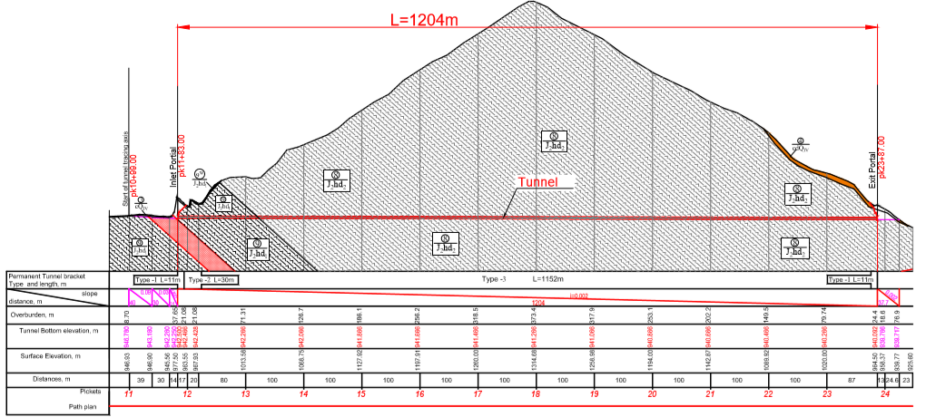
Figure 9. Type of tunnel finishing
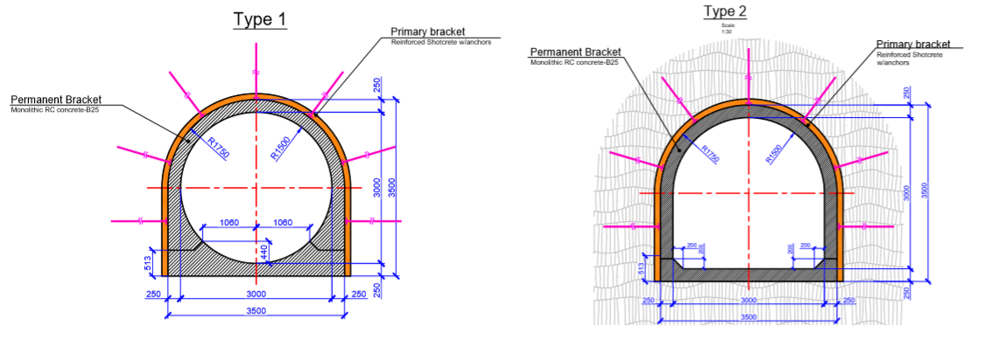

Figure 10. Plan of the entrance portal
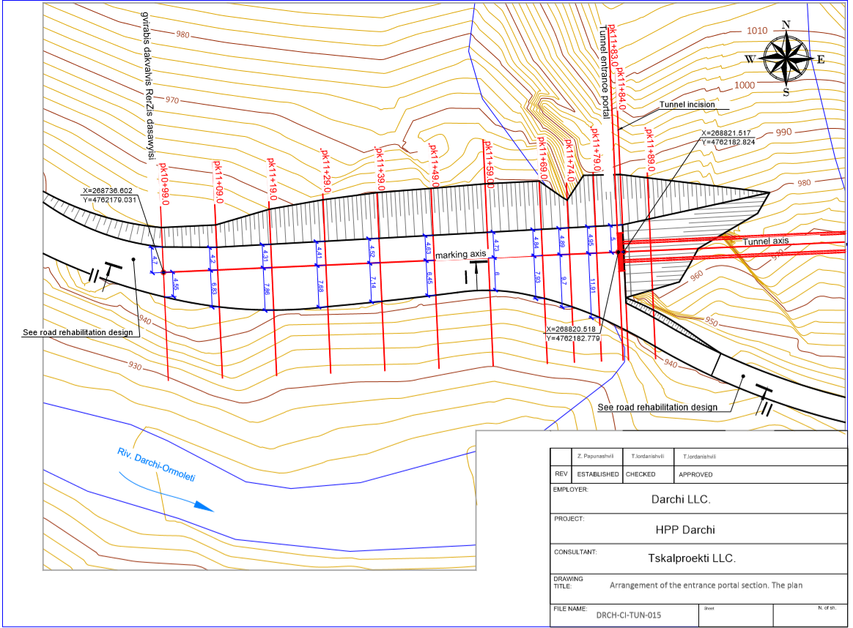

Surge Tank
Construction of Surge Tank (equalizing reservoir) unit is defined at a benchmark of 938.01 m above sea level.
According to the map of seismic zoning of the territory of Georgia, the construction site belongs to the 9 magnitude zone with a = 0.42 g design acceleration. Wind speed load w / norm = 0.23 kPa, snow cover weight p / norm = 1.45.
The Surge Tank relies upon a foundation plate on Layer-8 (andesite-basalt porphyritic lavas (80%), conglomerate-breccias (10%) and tuff-breccias (10%) - the second sub-suite J2hd2 of the middle Jurassic Khojali suite). The layer belongs to the rocky soil class). See the physical and mechanical properties of the soil in the Engineering Geological Survey.
The drawing shall be reviewed together with penstock and tunnel implementation drawings.
At the location of the Surge Tank, a mountain shelf should be cut and the cut slope must be reinforced to ensure it will not collapse. After that, the rocky soil should be cut off at the contour of the reservoir’s foundation slab followed by deepening it to the benchmark of 938.01. In the rocky soil, about 1.8 m must be cut out and deepened. The foundation slab must be anchored to the rocky soil to its full body. For that, the foundation slab will have to be concrete casted all around without any formwork and a surrounding soil will serve as a formwork. Above the foundation slab, a 10 cm thick leveled crushed rock layer and a 10 cm thick lean concrete layer will have to be implemented. After that, the foundation slab will have to be reinforced and concrete casted. After the foundation slab is concreted, a metal pressure pipeline will have to be implemented and concrete casted up to the benchmark of 944.11 after completing reinforcing of its walls. After that, reinforced concrete walls will have to be concrete casted all over its height. In all cold concrete joints, a water restrainer – water stops must be installed. In the reinforced concrete walls, those details required for installing a ladder and a metal roofing must be taken into consideration as described in the project. Those details will have to be installed in the wall prior to its concreting followed by concrete casting of the wall.
Load-bearing elements of the tank Include a reinforced concrete foundation slab h = 120 cm and reinforced concrete walls h = 50 cm. After installing a metal pressure pipeline, a gap between the metal pipe and the wall should be filled using secondary concrete.
The load-bearing structures, as a single spatial system, were calculated for constant and temporary loads, taking into account water as well as horizontal loads, wind loads and seismic impact, and their design composition. The calculations were performed using a certified reporting software LIRA SAPR 2015.
In the reinforced concrete structures, B35 grade concrete is used - waterproof W8 and frost-resistance - F150. Reinforcing steel - A500C grade;

Safety Valve
The pressure pipeline safety valve is located in a small enclosure building with dimensions of (WxLxH) 6.2x8.5x3.3 m. The building will be built near the Surge Tank, at a distance of 1.65 meters between the walls. 5 cm thick foamboard should be arranged at the point of contact between the valve control building and the Surge Tank structures.
The thickness of the foundation of the building is 35 cm, while the thickness of the walls and roof slab is 25 cm. The building has a flat roof, waterproofing materials are used on the ceiling. B30 F150 W8 concrete used for the construction of the building.

Figure 11. Plan of the penstock protection valve building foundation
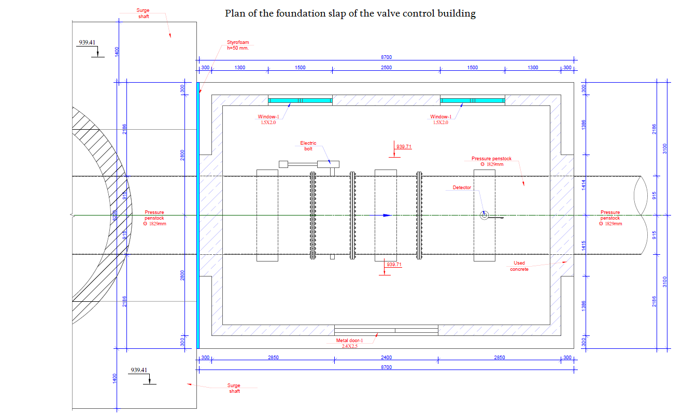

Penstock
The diversion-pressure system is of the combined type and represents the combination of the following elements: a pipeline from the headwork to the tunnel with an initial diameter of 2.0 meters, which then expands to 2.2 meters, then tunnel 3.2 meters in diameter, and penstock with 1.8 meters in the diameter which ends at the HPP building. Last part of the penstock is divided into two equal 1.8 m sections, followed by a consistent reduction to 1.6 m and then 1.2 m of pipes entering directly to the building.
The pressure pipeline is L = 443.1 m in length and is made of spiral stitched metal pipes with outer diameter Ø1829 mm, thickness δ = 14.5 mm.
The pipeline experiences turn along the entire length of the route at different magnitude angles, both in the horizontal and vertical planes.
The pressure pipeline is arranged in an open manner, the works of which are carried out in the following sequence: 1. A trench 50-60 cm deep is dug along the axis of the pipeline and the generated soil is removed; 2. A 20-25 cm thick sand cushion is prepared, on which a concrete canvas CONCRETE CANVAS CC5 is placed; 3. The metal pipe is mounted and the concrete canvas, which then will be strengthened.
The pipeline has six reinforced concrete anchors that will be placed on curves with large opening angles. The foundation depth of anchor-reinforced concrete blocks will be at least 2.0 meters underground. Also pipeline has reinforced supports, which are placed at the points where the pipeline is above the ground.

Figure 12. Longitudinal profile of the penstock
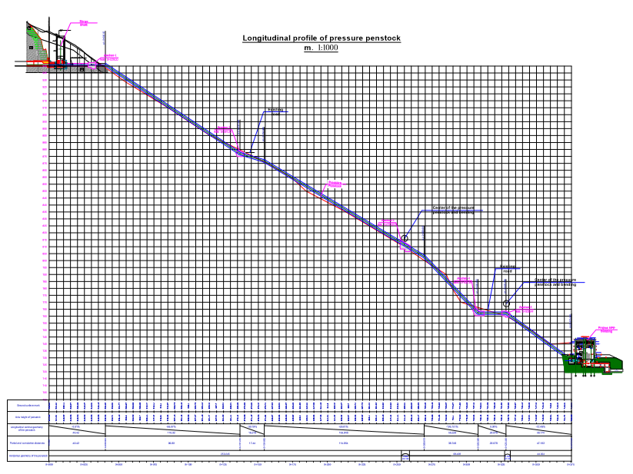
The entire length of the metal pipe shall be treated with anti-corrosion paint, the thickness of which shall be at least 32 microns.
The pipeline in 2 places will be placed underground. The first is on the Khaishi-Sakeni-Omarishara road, and the second is on the territory of the construction base (the construction base is arranged on a terrace cut on the slope there). The pipeline will be placed at the intersection of the existing road in the casing pipe (steel pipe Ø 2200 mm; δ = 14 mm, L = 8 m). Within the casing, 10 sliding supports are arranged on the pipeline, with steel strip (GOST 82-70) B = 185 mm, δ =14 mm, L = 300 mm; The supports will be located radially at the bottom of the pipe, at an angle of 450, with a step length of 2 m.

Powerhouse
Dimensions and design of powerhouse depend on the type and dimensions of turbine-generators installed in it. Two options are considered. According to the first option, two units of Pelton type vertical axis turbine, each of app 9 MW capacity, will be installed in the powerhouse. The design flow of each turbine is 4.80 m³/s, design net head - 200-210 m. Thus, the total capacity of the HPP is 2×9=18.0 MW, and the design flow - 2×4.8=9.6 m³/s.
The powerhouse will be located on the right terrace of Nenskra River. The turbine-generators installed in the powerhouse are supplied with water by means of d=1200 mm steel pipes.
The powerhouse elevation is determined in consideration of the fact that in case of construction of Khudoni HPP, the Nenskra River will be flooded with the Khudoni reservoir up to 723.50 masl elevation. As we know, the issue of renovation of the Khudoni HPP has not been resolved yet, so the date of completion of this construction is unknown. Thus, the location of the powerhouse was selected in such a way as to allow the operation of Darchi HPP both in the case of the Khudoni HPP construction and during the period before the construction of the HPP. Subject to this requirement, a motorway bridge, crossing the local waterway tract, will subsequently be moved to the site at the crossing point of the HPP waterway tract at a higher elevation point when the road is flooded with the Khudoni reservoir.
To prevent contamination of water with oil, lubrication of the working part of the turbine (turbine axis and bearings) is carried out with clean filtered water. Such a system of turbine lubrication is environmentally friendly and widely used in modern high-quality turbines. Therefore, the risk of contamination of water with turbine oil is minimal.
Generally, the generator is located in the machine hall, well above the water level and has no connection to the water. Lubrication of the generator bearings is carried out with oil placed in a closed circuit and spillage is excluded if properly operated.
In the event of an emergency, in the event of an emergency oil spill, the power plant will be equipped with a turbine oil drainage system from which spilled oil will be collected in the pits and pumped to the collecting tank. Spilled oils will be handed over to companies with relevant permits for further management.
An air-cooling system is used to cool the generators. For this purpose, at the end of the generator axis is a fan that blows the air from the machine hall. Heated air comes out of the powerhouse during the summer, and in winter it is used to heat the powerhouse.
The powerhouse is comprised of turbine-generator installation hall (machine hall), installation site and servicing and transformer rooms.
The machine hall is based on a single, monolithic concrete slab, the thickness of which varies from 2.4 m to 3.05 m (directly in the turbine-aggregate installation zone). At an elevation of 729.07 masl, 60 cm thick, monolithic reinforced concrete walls arranged on the perimeter of the machine room is based on this slab.
Above 729.07 masl elevation, the powerhouse will be arranged with sandwich-panel walls mounted on steel construction. The height of the building is 8,6 m. The machine hall and the installation site next to it have a double-sided inclined roof. Thus, the total height of the powerhouse is 10.95 m, and from the machine hall floor level 15.15 m.
Bridge crane with 45 t load capacity will be installed in the machine hall, which will move on the beam mounted on special support columns.

Figure 13. Cross section of the powerhouse building
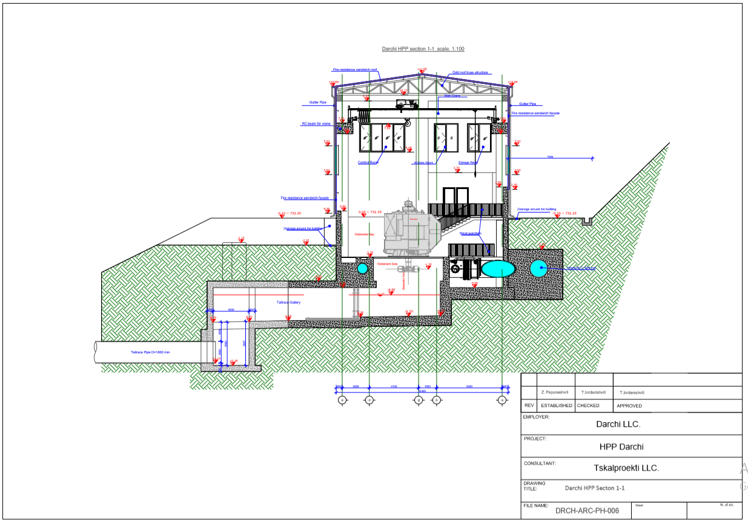
There will be windows on the facades of the walls for ventilating the machine hall. The powerhouse design also provides ventilation. The powerhouse will have a large 4.75 m wide door to allow the trucks access to the installation site. Also, it is also envisaged to install separate, non-machine front doors in the workshop and corridor area. From this corridor, it will be possible to get to any unit of the powerhouse.
Next to the machine hall, the so-called installation site will be arranged, which is 4.15 m higher than the elevation of the floor of the machine hall.
Along the entire length of the machine hall and installation site, a service and transformer room will be arranged. the length of the service room will be 8.0 m. Its height will be 2,65 m. It will have a one-sided tilting roof.
The roofing of both the machine hall and the installation site, as well as the service room, are made of special roofing sandwich panels mounted on the roof frames made of steel profiles.
From the powerhouse, the turbine water withdrawal tract will be arranged as an open channel that runs to the banks of the Nenskra River. A dissipation basin will be arranged at the end of the tailrace channel, due to the large slope of the channel. The route of the tailrace channel crosses the local road. A motor bridge is planned to be arranged at the crossing point.
At present, before the Khudoni Dam is constructed, the powerhouse is approximately 40 meters higher than the existing river bank elevation. Consequently, the tailrace channel has a large slope, thus requiring a dissipation basin at the end of the channel, from which the water flows into the riverbed. In case of Khudoni dam construction, the dissipation basin will lose its function as it will fall within the reservoir flood zone (Khudoni HPP flood elevation is 723.50 masl).

Tail water pipe
The tail water pipeline of the Darchi HPP starts in the powerhouse from the turbine water intake chamber.
The pipeline route is linear, without horizontal curves, it is arranged on a slope and ends in the stilling well on the right bank (slope) of the river Nenskra (pipe bottom elevation 687.20 masl). There are two vertical curves α = 30° on the route, where the arrangement of reinforced concrete anchor supports N1, N2 is designed. In the vertical corners steel U-bends α = 30° will be installed (D = 1800 mm, wall thickness δ = 14 mm).
The pipeline is arranged with steel pipe D = 1800 mm (wall thickness δ = 14 mm). The pipeline will be located in a trench with a base width of 3.8 m, slope inclination 1: 1. At the bottom of the trench are arranged gravel beds with a thickness of 20 cm. The trench is filled with the on-site treated soil. Excess soil will be dumped over a distance of 1 km.
The pipe wall thickness is determined based on the recommendations, according to which the stiffness of the pressure pipe is ensured if the condition D/δ ≥130 is met, where D is the inner diameter of the pipeline, δ is the wall thickness.
The stilling well is a site-cast reinforced concrete structure, square in plan, with internal dimensions of 6X6 m. The well bottom elevation is 680.70. The height of the well to the spillway weir is 5.4 m. The height of the rear wall of the well, at which the outlet pipe ends, is 9.3 m. In the front wall of the well, on the side of the river Nenskra, at the elevation of 686.10 masl mark there is a stilling weir, 5 m wide.
At the end of the outlet pipe, within the well there is arranged a 90° U-bend (D = 1800 mm, wall thickness δ = 14 mm) and stilling terminal (steel pipe D = 1800 mm; δ = 14 mm, L = 3 m, with 8 pieces of rectangular holes 80X60 cm).
At the bottom of the well, in the center, in order to scatter the flow of fallen water, a pyramid-shaped step is arranged h = 0.5 m, the lower base - 2X2 m, the upper - 1X1 m. The base and walls of the well up to the 686.10 elevation will be covered with steel sheet δ = 10 mm.
After the spillway, in the well downstream, in order to protect the slope from washing, a stone apron (h = 3 m) with rubble stone (D≥70 cm) is arranged. From the stilling well through the apron, water will enter the Nenskra River.
The dimensions of the stilling well are determined in accordance with the hydraulic report and the recommendations given in the special literature for similar buildings.
At the intersection with the existing road the pipeline will be placed in the casing pipe (steel pipe D = 2200 mm; δ = 14 mm, L = 8 m). Within the casing, 10 sliding supports are arranged on the pipeline, with steel strip (GOST 82-70) B = 185 mm, δ =14 mm, L = 300 mm. The supports will be located radially at the bottom of the pipe, at an angle of 45°, with a step length of 2 m.
Anti-corrosion coating is designed to be made on pipelines, casing pipe and other steel structures.
According to the engineering-geological report, in the area of the pipeline and stilling well, the base soils are represented by two layers:
- EGE3 - moist, sandy dusty-clayey gravel with the content of crushed boulders. ρ = 2.15 t/m³, E = 48 MPa, w₀ = 0.5 MPa. According to treatment - §6f.
- EGE 8 - andesite-basalt porphyry lavas (80%), conglomerate-breccias (10%) and tuff-breccias (10%). ρ = 2.66 t/m³, E = 15000 MPa, Rc = 71.88 MPa. According to treatment - §20b and § 18f.
The treatment of the spillway well pit will cause damage to the existing road and traffic obstruction. Therefore, a temporary bypassing road with a length of 106 m, a carriageway width of 4.5 m, a longitudinal slope of the road - 3.3%, 8% and 4.31% is envisaged. The feather edge road surface will be arranged with optimal sand-gravel mixture with a thickness of 20 cm on the axis. To avoid surface water flowing from the slope, an angular-shaped groove h = 30 cm will be arranged along the road.
The existing road will be restored after the construction of spillway well is completed.

Construction

Overview of the Construction Approach
The construction phase can be divided into the following main works:
- Preparation of construction camp, construction sites and mobilization of machinery and equipment needed for construction;
- Construction-rehabilitation of access roads;
- Major works:

  - Earthworks, preparation of foundations, excavation of a trench, management of excavated soil;
  - Tunneling;
  - Construction of permanent structures (headwork, penstock, power unit, power transmission line);
  - Installation of the Electrical and Mechanical Equipment;

- Reclamation works and preparation for commissioning of the buildings and equipment.

Construction Camps
Areas of construction camps are selected in the immediate vicinity of construction sites, on the ground with favorable terrain and engineering-geological conditions. It is important to use less valuable land in terms of vegetation; Sources of noise and emission shall be located as far as possible from the population, etc.
Taking into account the specificity of the pre-designed scheme and location of the construction organization, at this stage, the area adjacent to the powerhouse is considered for the main construction camp. This area is located on the right bank of the Nenskra River (approximate coordinates - X – 270368; Y – 4762404.). The layout of the area is convenient due to the proximity of the main construction sites (powerhouse, tunnel portal, surge tank). The nearest residential house (village Lukhi) is approximately 450 m from the border of the area.
The earth road leads to this area. The arrangement of necessary communications is not associated with significant difficulties.
According to preliminary considerations, the construction camp will include office containers, parking lots, open and closed warehouses, water supply and sewage systems, concrete unit, auxiliary workshop (it is not planned to use crushing-sorting plant). Temporary construction infrastructure (warehouses and auxiliary storages, machining areas, etc.) will also be located on the site of the headwork and near the tunnel portals.
The construction camp plan is shown in the Figure 14.
Construction sites of the transmission line will be supplied with towers, reinforced concrete structures, wires and others by road transport from the central construction base (construction site of Darchi HPP).
Workers' camp of Darchi HPP will be used to create living conditions for labor forth. Workers will be transported to construction sites by special passenger micro-buses.
It is planned to arrange a 60 m³ capacity concrete unit on the site of the construction camp. A 20 m³ capacity underground metal tank will be arranged to store diesel fuel.

Figure 14. Construction camp plan
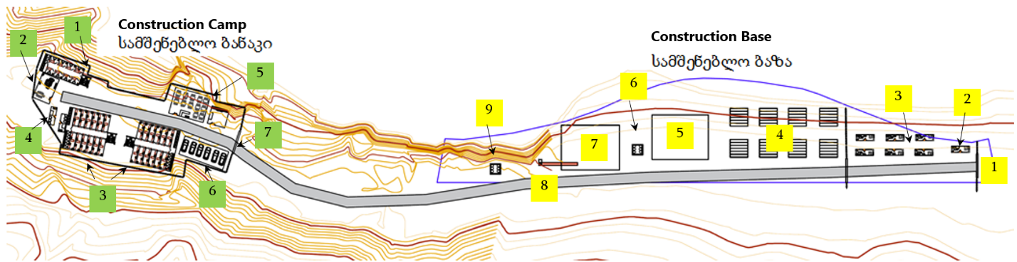

Construction Camp Plan | Construction Base Plan
- Three-story residential block for staff  - Resting room  - Two-storey residential block for workers  - Laundry  - Power supply and kitchen  - Parking  - Gate | - Gate  - Security booth  - Office space  - Pipe Warehouse  - Closed Warehouse  - Fuel supply tank  - Open Warehouse  - Armature cutting machine  - Hazardous Waste Warehouse

Access Roads
The main transport artery at the construction stage will be the Zugdidi-Jvari-Mestia-Lasdili highway and roads passing through the Nenskra gorge. Both roads are covered with a solid cover and are in good condition. It is noteworthy that there is an access road (earth road) to the headwork area. Consequently, the construction of new access roads within the project area will not be associated with large scale works.

New Roads
There is a need for the construction of a new road to the tunnel exit portal and surge tank, as well as it is planned to arrange roads at 6 different points from the tunnel exit portal to the powerhouse for pipeline construction purposes. Road width is 6 m. Road type - earth road. A schematic drawing of the new roads is given below.
New road layout from the surge tank and tunnel exit portal.
Figure 15. New roads plan
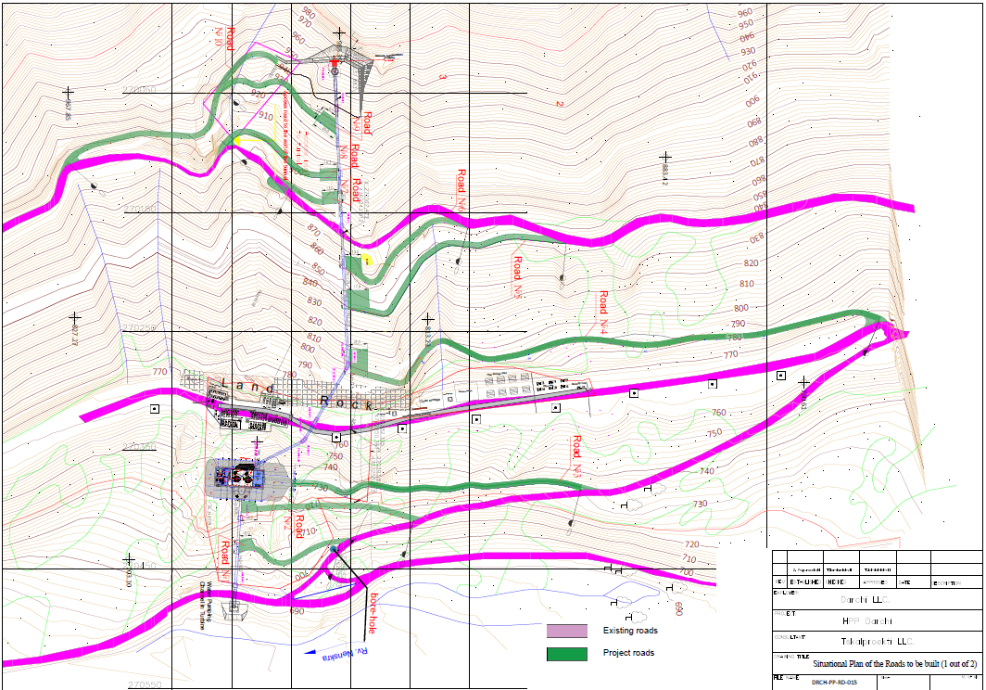
An access road to the pressure pipeline and HPP building starts from the existing soil roads (except Road #9 that starts from a projected Road #10). In total, 10 (ten) roads are designed with total length 1792 meters.
Roads #1 and #2 approaching a tailrace pipeline from HPP building to River Nenskra with the lengths 92.3 and 146.8 meters respectively. Road #3 represents a road to HPP building with the length os 246.7 m.
Roads #4 to #9 will be constructed to access the pressure penstock. The will have following lenghtes:
- #4: 471.4 m;
- #5: 214.0 m;
- #6: 129 m;
- #7: 43 m;
- #8: 109.0 m;
- #9: 118 m.
Road #10 represents the road to the outlet portal of the tunnel with length 221.0 m.
Road #7’s Earthworks volume includes a square in the beginning to be able to turn around a vehicles to the main road. A width of the carriageway is changeable and starts with 4.5 m. At the end sections of all roads, where construction works for different structures are planned, special sites will be set up for allowing vehicles to turn.
In order to avoid any unnecessary excavation works, we tried to use the existing relief to a maximum possible extent (landscape design); furthermore, we did not plan a two-sided slope for the road since in this case, soil culverts would have to be set up on the slope side and artificial structures would have to be designed. For removing drain water from slopes as well as atmospheric precipitates, a single-sided slope will be made according to the project.
The purpose of the projected roads is to transport construction materials to the construction site during the construction period and to carry out construction work, and later these roads will be used for operational purposes.
Capital type (a / concrete or c / concrete) pavement is not envisaged on the project roads. The strength of the existing rocky soil is sufficient to move the loads, and in the event that local small deformations (junctions) occur over time then it will be necessary to eliminate these deformations again using local soils.
The design also takes into account the low speed of traffic (about 20 km / h) and the road parameters (radii and slopes) differ from the requirements of the Georgian national standard. We also did not take into account the two-way slope of the road, because in this case it would be necessary to arrange ground ditches on the slope and design artificial structures to remove runoff and atmospheric precipitation from the slope.
Cutting of the slope shall be made at as inclination that according to the geological parameter of the soils can hold themselves without a special strengthening measures (main soil are rocky soil, which are covered by 0.2-0.3 m non rocky material.

Road rehabilitation
The project road starts from the headwork and ends nearby the Darchi HPP building. The project road is conditionally divided into two sections; the first one starts from the headwork and ends at the inlet of the pressure tunnel. The first section is 1377 m long. On this site, along the road, a pipeline consisted of 2200-2000 mm diameter pipes will be constructed.
The second section starts from the pressure tunnel inlet and ends nearby the HPP building. The second section is 4195 m long while its carriageway is 4.5 m wide. In order to allow oncoming vehicles to pass, the so-called bypasses will be arranged on suitable places (30.0 m long and 8.0 m wide).
No communications (water, gas, electricity transmission line) are located along the project sections, no connections and intersections are found. The project section was part of the road connecting Abkhazia, which is currently used for low-intensity extraction of timber.
The purpose of the rehabilitation of the project road is the smooth transportation of concrete and inert materials for the construction of the Darchi HPP head building, as well as the supply of water pipes with a diameter of 2.0 m and a maximum length of 13.0 m. The dimensions and radius of the project road are sufficient to transport these cargoes smoothly and safely.
Asphalt-concrete or cement-concrete pavement is not envisaged on the project road. The strength of the existing rocky soil is sufficient to move the loads, and in the event that local deformations (junctions) occur locally over time then it will be necessary to eliminate these deformations again using local soils.
Since there are mainly steep slopes on both sides of the road, in order to avoid excess excavation works, while elaborating the project, a roadbed of the existing road to the maximum possible extent were used. Furthermore, no bilateral slope was considered for the road since otherwise, an additional culvert line should have been arranged on the water pipeline side. According to the elaborated project, a single line of the reinforced concrete culverts will be in place between the water pipeline roadbed and the slope side on the 1st section of the Road. Reinforced concrete cuvette is 0.4X0.4 m internally.
To drain atmospheric precipitates from the carriageway, 500 mm diameter road-crossing metal pipes will be installed on the 1st section of the Road. At the pipe inlets, concrete wells will be installed and at the pipe outlets, concrete portal walls will be constructed (metal pipes are designed in four places in total, locations are marked on situational plans and longitudinal profiles).
For removing atmospheric precipitates from a carriageway on the 2nd section of the wall, it is intended to set up a single-sided 4.0% gradient that is inclined towards a slope.
No measures are taken to enhance the stability of the slopes during incisions, as incisions are made according to the physical-mechanical properties of the soil. (The main soils are rocky rocks covered with 0.2-0.3 m thick non-rocky soils).

Damping areas
During the construction process (especially during construction of tunnel and access road to surge tank), waste rocks will be generated that shall be stored.
It should also be noted that part of the generated ground will be used for the purposes of the project (including the arrangement of access roads and their periodic rehabilitation, construction of bank protection facilities, etc.).
Accessibility and distance were taken into account in the selection of areas for spoil grounds. Preference was given to:
- State-owned, non-agricultural land plots, in order to avoid the impact on private property and the need to change the purpose of the plot;
- Areas not distinguished in terms of vegetation and soil cover.
Due to the difficult terrain of the design area, finding a site that meets all of the listed criteria is difficult. Two sites with a total area of 25 400 m² and approximate capacity of 110 000 m³ were selected for spoil grounds:
Spoil Ground 1 - The area selected for spoil ground is located near the powerhouse on the first terrace of the right bank of Nenskra River, on the land plot between the river bank and the road. Its area is 8300 m², and the capacity - about 35 000 m³ waste rocks. The existing road will be used for the transportation of waste rock to the spoil ground, which excludes the need for new road construction. There are single tree plants in the area, and the fertile soil layer is practically non-existent (the surface is covered with boulders and gravel).
Spoil ground 2. The area selected for the second spoil ground is located near the village of Lukhi, on the land plot between the right bank of Nenskra River and the road. Its area is 17 100 m², and the approximate capacity - 75 000 m³ waste rock. The vegetation in the area is represented by individual species, and the fertile soil layer is practically non-existent. As in case of the first spoil ground, the surface is covered with boulders and gravel. The construction of a new road for the operation of the spoil ground is not a necessity.
Layout scheme of the spoil ground areas is given in Figure 16.
Within the boundaries of the spoil grounds, the waste rocks will be placed in compliance with the following conditions:
- Waste rocks will be transported by trucks;
- Safe transportation of vehicles to the spoil ground will be ensured;
- Waste rocks will be transported to the spoil grounds by strictly adhering to traffic rules and minimizing vehicle speeds (5-20 km/h). If necessary, the movement of vehicles will be regulated by specially trained regulatory staff;
- The humus layer of soil (if any) shall be removed and stored separately in a protected area prior to the storing of the waste rocks;
- Waste rocks will be stored into sections, layer by layer;
- The height of each bulk (fill) will not be more than 2 m and the slopes will not exceed 45⁰. Otherwise, additional measures for bulk slope protection and reinforcement will be used;
- The boundaries of the allocated area shall be strictly controlled to ensure that no waste rocks are placed outside the perimeter and no vegetation is damaged or the riverbeds are blocked;
- After the spoil grounds are filled, reclamation works are planned on its slopes and surface;
- After the spoil grounds are closed, observation of the development of erosion processes will continue and appropriate corrective action will be taken if necessary.

Prior to commencement of work, the construction contractor will be required to prepare the project of spoil grounds and management plan.

Figure 16. Locations of spoil grounds
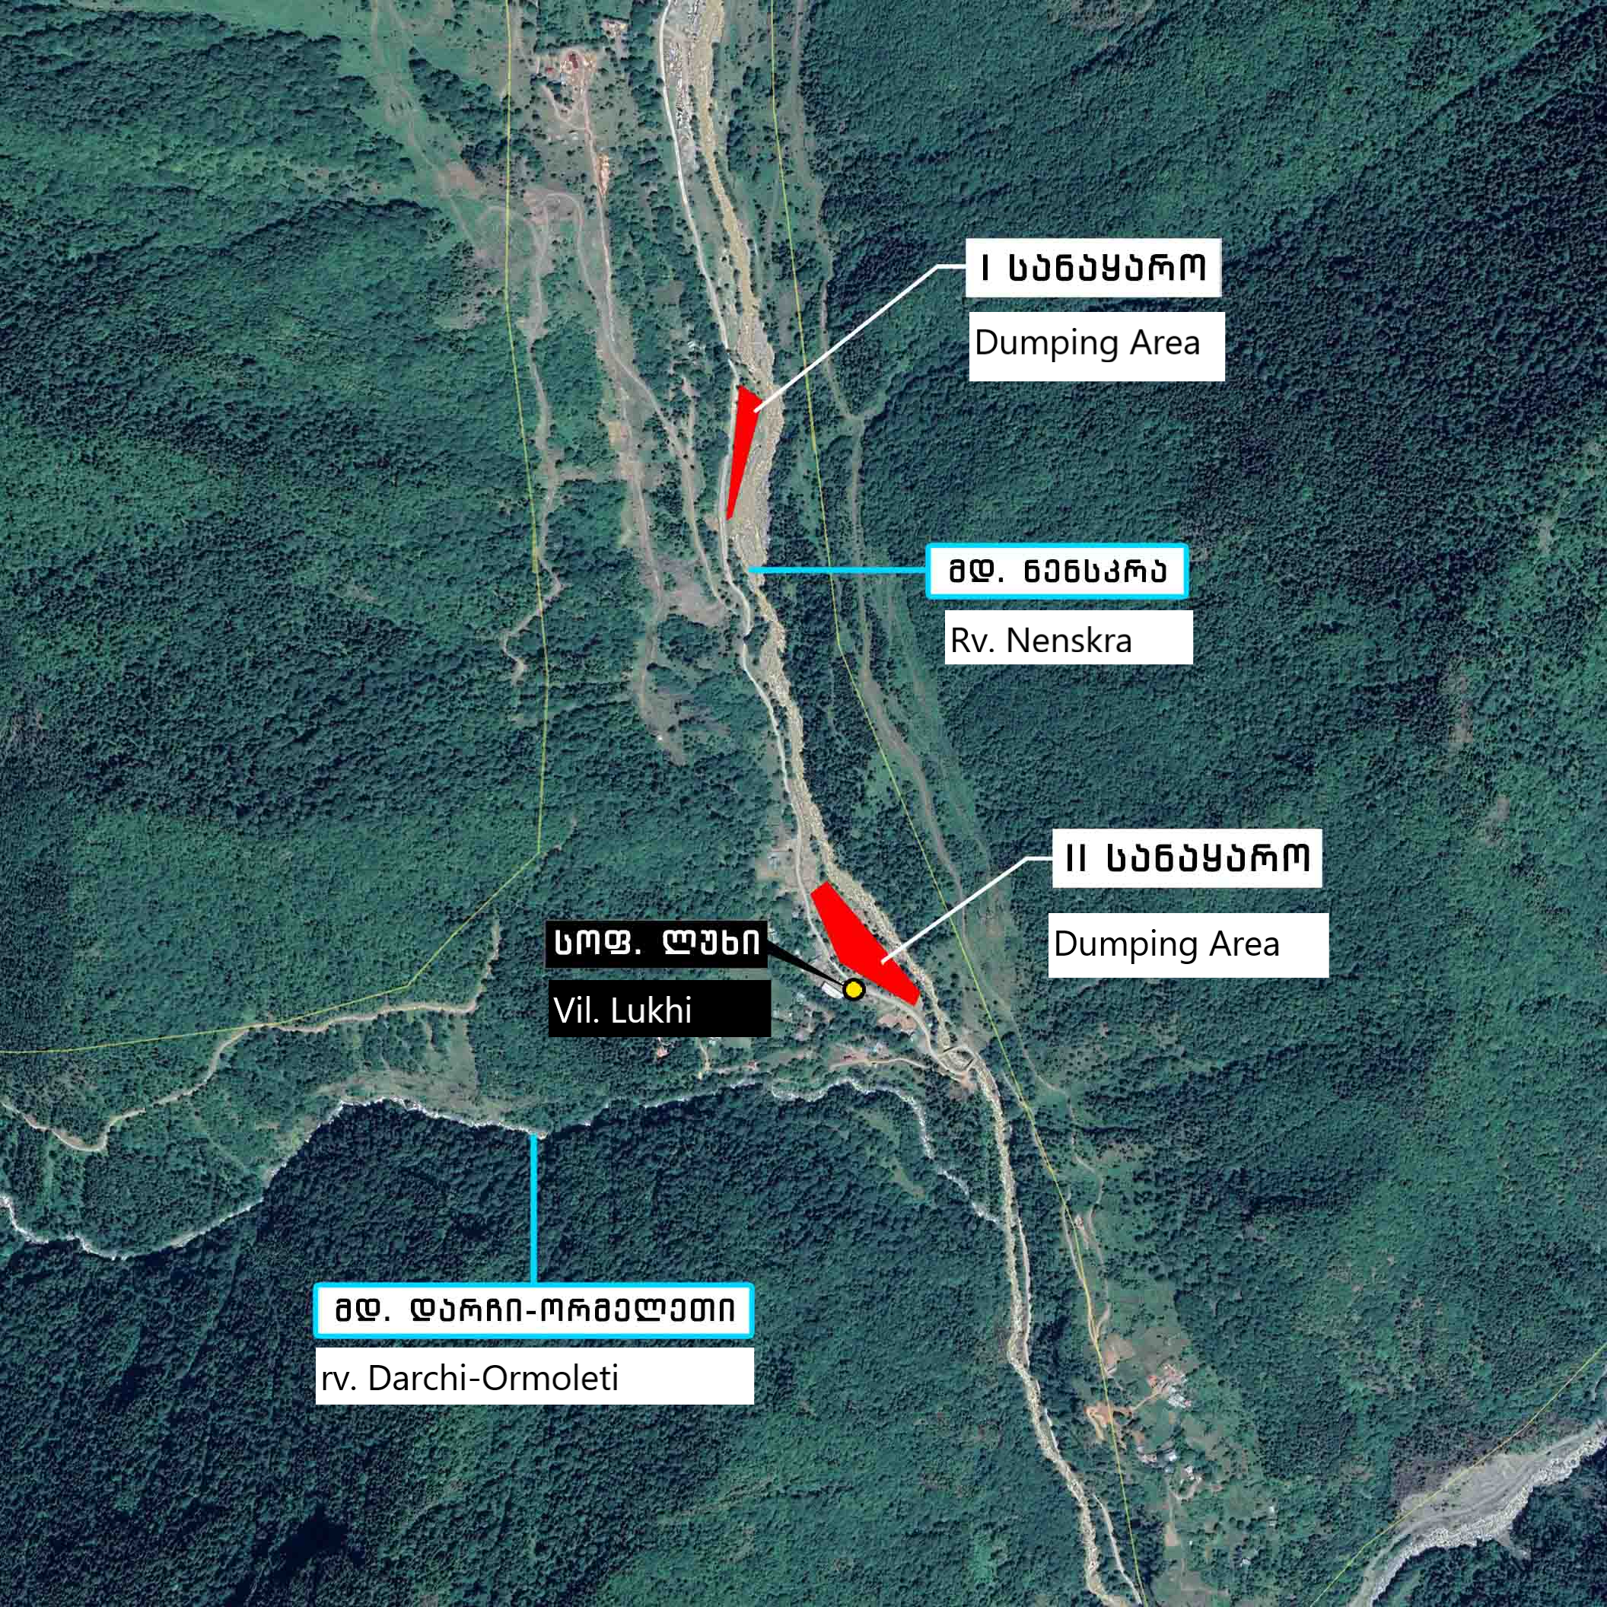

Headwork’s construction organization
The construction of the headwork will be carried out in stages, in separate blocks. During the construction period, water flows will be drained by arranging first and second-order cofferdams and a tailrace channel.
First of all, gated part of the intake and sediment basin will be constructed. For this purpose, a crib cofferdam with a height of 3.5-3.0 m and a width of 2.5 m is arranged along the riverbed. The tailrace channel with bottom width of 5 m will be arranged in the earth bed on the right bank of the river. The tailrace channel provides approximately 105 m³/s of water flow. A temporary dam will be arranged on the left bank of the channel. The average height of the dam is 3 m, crest width - 4.5 m, and slope inclination - 1:1, which will also serve as the access road for the second stage construction. At the end of the dam, 3 steel pipes D=2000 mm, δ=12 mm, length - 12 m, will be arranged at the beginning of the pressure penstock, which will ensure the release of water flows at the second stage of construction.
Second-line water flows will be released through the already constructed gated part. The first line cofferdams will be demolished and the second line crib cofferdam will be arranged, the height of which varies from 3.5 to 4 m, width 2.5 m. Then, the spillway, fish way and the right bank wall will be constructed. After completion of headwork construction, cofferdam and the temporary dam will be demolished. Steel pipes will be used for the construction of the penstock.
The crib cofferdams will be arranged with 20x20cm wooden beams. The crib cofferdams will be filled with on-site processed ground. At the base of the concrete structures, it is planned to arrange a 10 cm thick gravel layer and a 10 cm thick concreteს (B 7.5) preparation.

Construction of diversion pipeline
The pipeline will be arranged in an open manner. At first, the topsoil will be removed, an excavator will be used to pull out the tranche. At rocky sites, a small charge explosion will be used for further excavation. Manually prepare the trench bottom before arranging the pipeline. The foundation will depend on the geological profile of the pipeline route.
After placing, installing (welding), testing, and dyeing the pipe in the trench with the excavator and crane, the trench will be filled with processed ground backfilling and hardening, with a compaction coefficient of not less than 0.95. At sections where the penstock tranche falls within the existing road boundaries, the rack will be widened to ensure the movement of construction equipment. At such sections (pk1+46.1–pk1+96.2) the road will be restored with the local (processed) ground with a compaction coefficient of not less than 0.95.

Construction of penstock
The pipeline from the tunnel exit portal to the powerhouse will be based on specially designed concrete supports. The pipeline between the supports will be reinforced with anchor clips. Concrete for anchor blocks will be supplied with concrete trucks, and the concrete pumps will be used for filling. At steep sites (after the tunnel), the rope crane will be used for pipe installation.
A concrete channel will be arranged along the pipeline, which provides for the removal of atmospheric precipitation and condensate from the pipeline. The channel constructed along the pipeline will be connected to the main channel of the HPP through which it flows into the Nenskra River. This section provides for the installation of compensators to provide flexibility for the pressure pipeline during atmospheric impacts. After installation of the pipeline, it shall be tested for the design hydrostatic and additional hydraulic shock load.

Construction of tunnel and surge tank
As mentioned, the construction of the underground infrastructure of the HPP (tunnel, surge tank) is planned by drilling-blasting method. The stages of the work cycle are shown in Figure 17.
Figure 17. Tunnel drilling-blasting method cycle
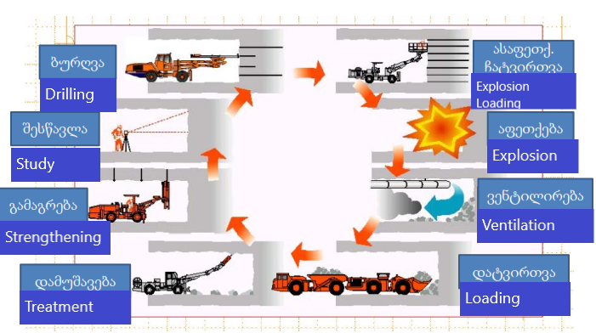

Trucks will be used to remove waste rock. The volume of material to be removed and temporarily and permanently stored on the spoil ground is 12 700.00 m³.
Its 10% will be used for backfilling (powerhouse, headwork wall, pipeline). Large boulders can be used for bank protection.
During tunneling, the tunnel arch and walls will be reinforced. Permanent tunnel supporting structures are selected based on the geological structure of a particular section.
As noted, the tunnel will be constructed by the drilling-blasting method. Drilling diameter will be up to 42 mm, borehole depth - 2 m. The depth of the cut after the blast should be at least 1.8 m.
The calculation results show that when tunneling with drilling-blasting technology, the mass of the explosive charge along with the blast wave propagation speed shall be limited, which according to the calculation results is equal to:
- Qmax = 8 kg;
- $Vmax=0.132$ m/s.
Ground processing in a tunnel should usually be performed by a contour blasting method.
The compressed air in the tunnel is supplied by a pipe through a stationary compressor mounted adjacent to the portal; However, the compressed air pressure for normal operation of equipment and pneumatic tools shall be not less than 0.6 MPa.
The exploded rock will be loaded onto wagons that will be transported by a 600 mm wide railway to the unloading site near the portal. The removed rock will be loaded on the dump truck with a 0.6 m³ load capacity excavator and will be transported to the final spoil ground. It is also possible to transport waste rocks by the so-called small dumpers. It is planned to arrange construction sites at the entrance and exit portals of the tunnel (since construction works will be carried out from both portals), which will house all the buildings, installations and equipment needed for both construction work and electrical transport. After removing rock from the blasted section of the tunnel, temporary reinforcement shall be ensured at weak sites in the form of reinforced concrete anchors, reinforcing mesh or steel frames, according to geological conditions.
The spacing and direction of the temporary and permanent reinforced concrete anchors provided for in the design may be adjusted according to the geological conditions identified during the tunnel construction. The construction company performing the underground works shall draw up a temporary reinforcement passport, which shall include: the type and length of the anchors, their orientation and the distance between them.

Operational control of the anchor bolt arrangement includes the following:
- Control of the depth of the borehole;
- Control the borehole direction with an accuracy of 10 degrees;
- Control spacing between boreholes with 10 cm accuracy.

Drainage water from the tunnel exit portal will be drained by gravity, while from the entrance portal - through pump installations. Sewage pits will be arranged in front of the portal and water purified from the suspended particles will be discharged into the natural ravines and then through the entrance portal into the Darchi-Ormeleti River, while from the exit portal - water will be discharged into the Nenskra River through sediment basin. The parameters and structure of the sediment basin will be specified on the basis of the volume of inflow water.
According to the proposed tunnel construction scheme, electrical and pneumatic devices and equipment are selected to perform the work, creating better working conditions. Drilling should be performed with water to prevent dust.
Construction sites are planned at the entrance and exit portals of the tunnel with an area of about 600-700 m². The following infrastructure will be located on the sites: Ventilation units, diesel generators, sewage pits (500-600 m³ capacity) for drainage waters from the tunnel, technical water reservoir (10 m³ capacity), temporary warehouse for explosives, parking, biotoilets, etc. Construction sites will be supplied with water from Nenskra River through auto tanks. Bottled water will be used for drinking.
Diesel generators will be arranged at the entrance portal for power supply, while the outlet portal will be supplied from the construction camp area. The wastewater of bio-toilets will be discharged into the sewage pits of the construction camp.

Water supply, wastewater and waste
During the construction of the HPP, water will be used for both drinking and technical purposes.
The highest demand for potable water will be in the main construction camp area. The rest of the drinking water will be consumed at different construction sites. Water supply tank will be arranged on the territory of the main construction camp. Bottled water will be used for drinking purposes on the territory of the construction camp and site and construction drinking water.
The approximate amount of drinking-industrial water consumed depends on the construction staff and operating mode: The approximate duration of construction will be 30 months (≈800 days). Approximate number of employees: approx. 120. According to Construction Norms and Regulations "Internal Water Supply and Sewage" of buildings – СНиП 2.04.01-85, water consumption per employee is 45 liters per hour for 8 hours. Consequently, the flow of drinking-industrial water will be:
120 × 45 = 5400 l/d, or 5.4 m³/d; 5.4 × 340= 1836 m³/a.
During construction, technical water will be used mainly in the construction camp area: for the preparation of the concrete mixture. River water is likely to be used for technical purposes. Water consumption for technical purposes, depending on the water demand practices of similar facilities, will depend on the capacity of the used concrete plant. (According to the practice of similar facilities, the rough estimate of the maximum daily water consumption of technical water will not exceed 100 m³). Assuming that the concrete plant operation time will not exceed 180 days per year, the amount of technical water used will be 18,000 m³ per year.
The technical water will be used for firefighting purposes and for watering the surfaces of roads and construction sites in order to prevent dust emission. The total amount of water used for these purposes will be approximately 6,000 m³/a.
In order to collect the wastewater generated in the construction camp area, a 15 m³ capacity hermetic sewage pits are planned to be arranged, which will be discharged on the basis of the agreement signed with Zugdidi Water Company.
Prior to discharge into the surface water body, wastewater generated during the tunneling will be treated, for which sediment basins of approximately 650-700 m³ capacity will be arranged at the portals. Water received from the entrance portal of the tunnel will be discharged into the river Darchi-Ormeleti after the treatment, while the water received from the exit portal will be discharged into the Nenskra River. During the construction mobilization process, when specific engineering solutions for the water discharge are identified, draft of maximum permissible discharge norms shall be prepared prior to construction and agreed with the Ministry of Environmental Protection and Agriculture of Georgia. During the tunneling process, the pH of the water will be controlled.

Construction schedule / interface management
Darchi LLC will be carrying out the tendering process to identify the main contractors to be engaged in the works, deliveries and services required to ensure the construction of Darchi HPP. As a result of this selection process, Darchi LLC will tender out and select contractors for the main works’ packages:
- Electro – mechanical equipment supplies;
- Hydro-mechanical equipment + Steel and piping wotks;
- Roads, excavation and Civil works;
- Tunneling.

For these works Darchi LLC will invite International and National suppliers. Especially when we are talking about E&M Equipment and Steel Supplies.
All the works will be Supervised and Quality Controlled by the designated Engineering Team. Works will be fully monitored to meet all the internationally and State recognized H&S standards. Site will have designated H&S Manager and several officers to conduct entire site monitoring. All the processes of Risk Assessment and Permit to Work procedures will be applied and recorded. Full Environment and Social monitoring process will be applied on regular bases.
Project Construction is planned to commence in March 2021 and Completion for operation (COD) is anticipated by January, 2023.
Works will be performed with various contractors for the specific work scopes, thus smooth transition is rather important not to jeopardize the progress of construction works and arrive @ COD date smoothly.
Works’ schedule is displayed in below given time chart. All the contractors will be given and obliged to fulfill key dates requirements, i.e. complete works on the date which will be stipulated into the contract.

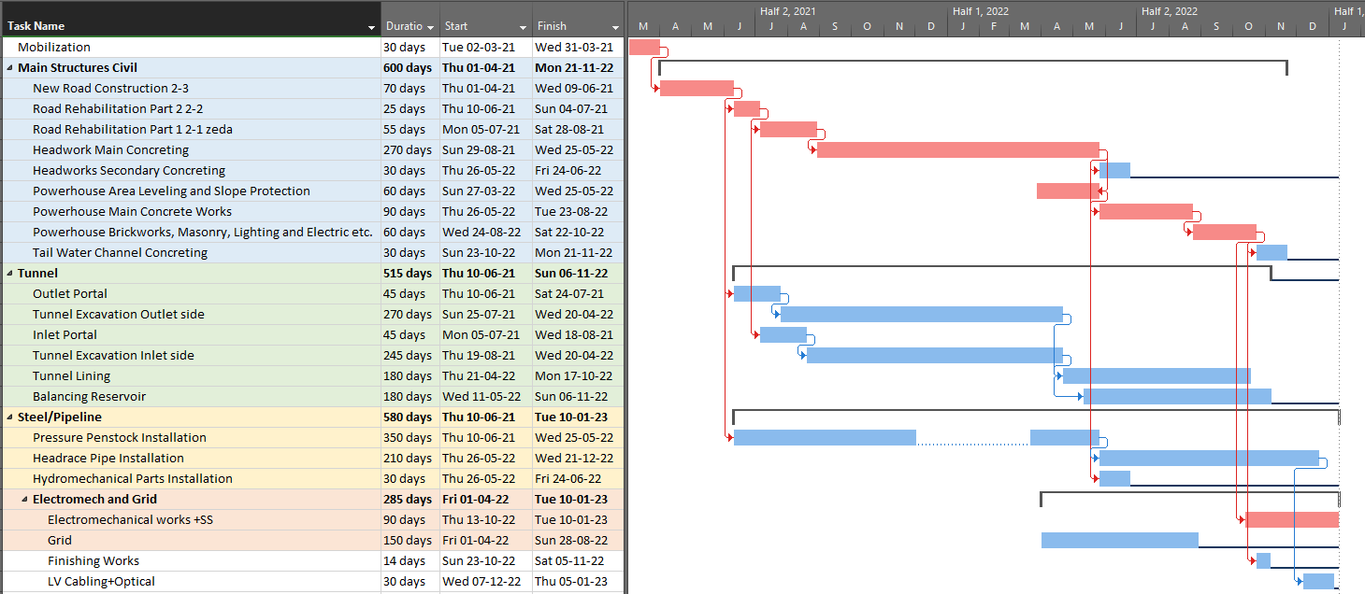
Figure 18. Baseline Timeline Gantt chart

Health and Safety (H&S)
Darchi HPP’s H&S management system will be an integrated part of the overall GGU’s safety management system. The H&S management system has been designed to ensure the successful delivery of GGU’s and Darchi LLC’s H&S commitment, expectations and legal compliance.
Darchi LLC HSE management System contains the following:
- OH&S management plan;
- Clearly defined roles and responsibilities for H&S personnel;
- Safety inspection / audit program;
- Risk management;
- H&S monitoring;
- Management to control change in the workplace;
- Emergency response planning for all working locations;
- Health awareness training;
- Technical integrity;
- Clearly defined recording and reporting process;
- H&S plans of the project.

Continuous development of plans, procedures and initiatives are implemented to deliver the ‘Step Change’ in order to achieve GGU’s safety performance on the project.
Darchi LLC aim to achieve the following H&S performance standards throughout the contract period:
- Zero fatalities;
- Zero days away from work cases (DAFWC);
- Zero lost time incident frequency (LTIF);
- Zero medical treatment cases;
- Zero vehicle accidents;
- Compliance with the H&S plans at contract and project level;
- No risk to, or interference with, local residents and enterprises.

Covid-19 prevention
To reduce the impact of COVID-19 outbreak conditions on Darchi HPP it is important to plan for COVID-19.
Georgian National Center for Disease Control and Public Health (NCDC) and Labor Conditions Inspecting Department (LCID) of Ministry of Health (MOH) of Georgia, developed control on COVID-19 preventions and elaborated regulations for various fields, including construction.
NCDC makes control on COVID-19 management all over the country. Fever centers and COVID-19 hospitals are mobilized in Georgia at the moment, under control of NCDC. Fever centers are clinics, where people with COVID-19 symptoms are mobilized for PCR Testing. If PCR tests gives positive result, person will be mobilized to COVID-19 control clinics.
The labor activity during construction is characterized by constant variability of workplaces and labor activities in open areas.That is the reason why, in terms of the spread of the virus, construction belongs to the medium risk sector, since its specifics include natural ventilation.
Nevertheless, it is important to consider the following preventive measures when working on Darchi HPP:
- Develop site specific COVID-19 emergency action plan outlining the measures to be taken to prevent the spread of the virus, as well as the measures to be taken in case of suspicion of the virus;
- Provide information to employees and third parties (who are present or may be at work);
- Safe working procedures and prevention of virus spread;
- Preventive measures developed on site;
- Proper use of personal protective equipment and hygiene products and its subsequent storage / removal;
- Post information about COVID-19 prevention measures in the workspace;
- Place disinfecting barriers at the entrance of the offices/living room/dining room etc, indicating the appropriate mandatory sign;
- Maintain thermal screening at the entrance of offices and site location;
- Ensure hand hygiene in the workplace and inform employees about;
- Ensure hand washing in the workplace using liquid soap;
- If hand washing is not possible, at least 70% alcohol-based hand sanitizer should be used for hand cleaning / disinfection;
- Place hand hygiene products in the appropriate place and the rules for their proper use;
- Ensure that employees have access to hand hygiene products and know how to use them in accordance with the relevant rules;
- Provide employees with the necessary personal protective equipment (special clothing, special footwear, helmet, gloves, medical mask) depending on the specifics of the job and establish control over their use;
- Periodically, several times a day, provide natural ventilation of enclosed spaces / storerooms;
- Disinfect frequently working equipment, inventory, working tools and workplaces at regular intervals;
- Arrange ergonomics. Ensure that the workspace is arranged in such a way that employees and / or other persons in the workspace do not encounter any obstacles during the work (including timely cleaning of the facility and timely removal of construction waste);
- Dispose of wipes or other used hygienic waste in hermetically closed containers for employees and visitors at work area.

Occupational H&S management plan
Site specific occupational H&S management plan will be developed. The main objective of project occupational H&S management plan (OH&S) is to provide an overview of the structured approach to be used in the prevention and minimization of occupational H&S risks. This OH&S plan outlines the organization and arrangements for managing H&S issues for the Darchi HPP within the site locations. The purpose of this document is to define Darchi HPP’s Occupational H&S objectives and commitments to the project requirements. The arrangements will be put in place to meet national and international regulations and operating standards and present H&S information in compliance with project OH&S requirements.
This plan will identify the arrangements in place, procedures to be adopted by Darchi LLC in compliance with project H&S requirements and will include the following information:
- The organization and contact details of the personnel with responsibilities under the contract;
- Details of the H&S responsibilities of the identified personnel under this contract;
- Risk assessment of the activities to be completed;
- The H&S procedures to be adopted to minimize and manage identified risks.

The plan will ensure the alignment of the interfaces between the HSE management systems of Darchi LLC and the Contractor (for construction activities) and make sure that there is a clear definition of how all activities will be managed. Risk analysis are conducted and agreed by both parties in order to assure safe and environmentally acceptable working conditions for all personnel involved in these activities.
The OH&S movement plan will be produced in accordance with the international standard and Georgian Organic Law of Occupational Health and Safety. The plan will be regularly monitored, reviewed and updated by Darchi LLC and GGU, in conjunction with its client and contractors, throughout all stages of project implementation.
Training
HSE training has been identified as a key element to achieve “a step change” in H&S performance. Therefore, it is a requirement for all personnel to undergo a minimum level of H&S training and/or demonstrate past experience of receiving such training. It is the responsibility of the GGU’s HSE manager to ensure all personnel have received the required training as indicated in GGU HSE training matrix.
In order to ensure the necessary level of training, a Training Needs Analysis has been performed for this scope of work and the training program has been developed as a matrix.
All personnel assigned to the positions identified in the Matrix have to complete the training and/or demonstrate sufficiently that training has been undertaken, prior to mobilization for the works.
In addition to the training identified in the training Matrix, all construction related personnel should attend the general job-specific HSE Induction provided by the GGU’s H&S manager prior to the commencement of work. Additional training will be held for supervisory level, where leadership issues and job safety analysis are highlighted.
Based on the contractual scope of work, the safety induction training provided to the nominated Personnel consists of the following topics:
- H&S induction;
- Emergency response;
- Safe driving rules;
- Welding safety requirements;
- Blasting safety;
- Working with heavy equipment (plant on site);
- Excavations and trenching;
- Working at heights;
- Manual handling;
- Fire safety;
- Electrical safety.

For supervisory level the additional training will include:
- H&S systems management;
- Incident management system;
- H&S contractual requirements;
- Incident investigations.

Additional job specific safety trainings will be provided to specific workers such as welders, fitters, operators etc.
All visitors will be provided general safety induction describing safety requirements, restrictions and PPE requirements. Visitors log will be maintained on site.
Personnel operating machinery such as excavators, trucks, cranes etc. should have appropriate experience and training and should have documentary evidence (e.g. licenses) where applicable, for the operation of the equipment. Evidence of training and licenses as well as training records shall be maintained in the construction manager main office.
Construction team will be trained in accordance of occupational H&S management plan. Training will be delivered by GGU’s H&S team.
H&S supervision
Construction activities will be performed under supervision of GGU H&S team. Contractor H&S obligations and rules should be in accordance or GGU’s H&S system requirements. It will be obligatory to present H&S certified officer on construction site and develop permanent supervision of construction activities. GGU’s H&S team will conduct weekly audits on construction site and provide audit report to H&S manager and construction company management, outlining all findings with determination of implementation measures and dates of improvements.

H&S risk assessment
Risk assessment will be performed for construction activities in order to reflect how the identified H&S hazards and risks are to be managed throughout Darchi HPP’s construction Project.
The project operates H&S management on a “risk based approach” and identification of hazards, the assessment of their risk and the identification of safeguards to prevent and control the risks is the key to the success of this Project.
GGU’s H&S manager, H&S representatives and contractor site representative will review the Risk Assessments, prior to commencing mobilization to work at site and shall be responsible for ensuring the Risk Assessments is communicated to all personnel who will be involved in the job scope.
Where additional hazards are identified and/or changes to the scope of works are made, the Risk Assessment has to be revisited and/or supplemental risk assessments performed. All changes will be reviewed and authorized by the GGU’s H&S manager.
The safeguards and measures identified in the Risk Assessments to be form the basis of H&S inspection/audit checklists which will be performed during the execution of the Project.
Risk reduction measures will be identified and the results of the risk assessment will be incorporated into the work performance and further reflected in the topics of toolbox and trainings.
These will be documented and conducted with a team of personnel who will be responsible for the day-to-day job activities. The Risk Assessment will be used to communicate to the workforce performing the task the H&S hazards and control measures to be implemented prior to the commencement of work.
All personnel will be encouraged to participate in hazard management and the project will adopt the use of the hazard-spotting /near miss reporting scheme based on the company “STOP” scheme.
As Risk Assessment determines preventive measures of existing hazards, monitoring of implementation of each measure will be responsibility of construction manager and site safety officer.
Additionally, Task Risk Assessments will be performed for activities, where simultaneous works or high hazards will be defined (excavations, blasting, complex lifting etc).

Toolbox talks
Awareness will be maintained as necessary through team-building sessions, inductions and training to ensure effective and competent personnel are assigned to the appropriate scopes of work.
All employees should be fully aware of the consequences of unsafe acts and unsafe working conditions and should at all times make every effort to eliminate them. Awareness / induction meetings / toolbox talks will be held, for timely orientation of the workforce as part of the continual improvement program to reinforce:
- Procedural understanding;
- The risks associated with the relevant work scope;
- Operations objectives (including key technical requirements).

Prior to commencement of any work under the Contract, Contactor H&S Officer on daily basis will inform its personnel of:
- The working conditions at the site, including the hazards and risks associated with the services, and the H&S management systems used as safeguards, including without limitation the H&S Plan;
- The need to immediately notify their supervisor of all H&S risks, which they believe not to be under adequate control.

Incident investigation and reporting
The main objective of such an investigation is to analyze the root causes and make recommendations to prevent recurrence of a similar incident. It is not to attribute blame.
Darchi LLC expects that all employees and work teams will provide prompt notification and reporting to management of the following types of incidents: Near miss; First-Aid Injuries; Medical Treatment Injuries; Lost-Time Injuries Workplace injuries and illness; Fatalities; Fires; Property Damage; Security breaches; Vehicle Accidents; Spills and leaks etc.
In the event that either an “incident” or a “near miss” occurs the reporting procedure is adopted (OH&S Plan).
All events resulting in harm to people, industrial illness and damage to assets (together with near miss events in these categories) will be verbally reported immediately to the Darchi LLC senior site representative, who reports to GGU H&S manager.
Any incident may undergo further investigation on receipt of the incident report, where the incident has resulted in a 1-workday (or more) lost time injury. The Darchi LLC will conduct a full investigation of the accident (workday includes actual work hours on site and travel to/from the site).
All incidents will be properly documented and reported. Darchi LLC will use incident reports to achieve goal of improving safety performance in the workplace, which benefits all employees. In addition, Darchi LLC will maintain records of injuries and illnesses in order to meet the requirements.
Determining the causes of incidents is an important process that supports ultimate goal of accident prevention. Only high-quality determination of the cause(s) of incidents in operations can eliminate or reduce the risk of recurrence of the same type of incident. The process starts with identification of events that might otherwise be considered “minor mishaps” that result in no real damage or injury. We call these events “near miss.”

Emergency preparedness and response plan (EPRP)
EPRP will be produced in accordance with the international standards and Georgian regulations. The document EPR will be regularly monitored, reviewed and updated by Darchi LLC and GGU H&S team.
The purpose of EPRP is to help prevent incidents, to assure preparedness in the event incidents occur, and provide a systematic response to emergencies.
This plan will identify equipment, training and personnel required to protect all personnel (including visitors and subcontractors), neighbors and the public during emergencies.
EPRP has the following objectives:
- Protect individuals, inside and outside of Darchi HPP construction areas;
- Save individuals inside the site premise;
- Limit damage to a minimum (environmental and economic damage);
- Contain and control the consequences of the accident;

EPRP will include provision for emergencies involving, but not limited to:
- Protection from COVID-19 virus and spreading at sites and camp and action in case of virus confirmation;
- Medical emergency;
- Fire;
- Explosion;
- Security issues such as civil unrest or terrorist activity;
- Hazardous material (oil/chemical) spill or release;
- Earthquakes;
- Electric shocks/electrocution;
- Severe weather (storm, flooding).

Reporting
GGU’s H&S manager will prepare and submit a weekly and monthly H&S report to the project manager. This report will be compiled in accordance with the project H&S performance reporting procedure (OS&H plan). The report will present details of the H&S performance for the previous week and summary of H&S activities performed in the previous month and as a minimum will include:
- Training provided in the last month;
- list of supervisors undertaking supervisory duties ;
- Previous Weekly and Monthly H&S Statistics and KPI’s ;
- H&S audits and inspections performed in the previous month.

H&S audits and inspections
GGU H&S Manager will ensure that, all activities are managed and monitored effectively and H&S performance is improved continually. To achieve it, H&S management system will be reviewed by Darchi LLC and GGU’s management periodically. H&S reviews will be performed as follows: H&S inspections and safety audits.

H&S system audits
Darchi LLC and GGU’s H&S team will conduct internal H&S audits.
The project management team at all levels will respect to rigorous H&S audit schedule, which also includes all contractors and their subcontractors (if any).
Audits and Inspections are imperative that personnel are given and understand written, visual and oral instruction from management and supervising levels to the workforce and individually between parties.
Audit will be held on monthly basis including assessment of effectiveness of preventive measures, OH&S Plan requirements, implementation of safety rules as defined in OH&S plan.
Audit results will be communicated to Darchi LLC and GGU management and improvement plan of finding will be agreed with timeframe.

PPE
Some work operations involve the use of potentially harmful materials and thus the wearing of protective clothing or use of protective equipment becomes mandatory. All PPE will meet or exceed International Standards (BS, ANSI, AS, DIN, CE) and will have the appropriate stamp/ID on the equipment.
All construction personnel, contractors and visitors will always have access to the following PPE:
- Safety footwear will have a minimum ½" heel and comply with approved EC standard;
- Hard hats (helmet) will comply with EC standard;
- Safety glasses will comply with EC approved standard and will have side shields;
- High visibility jackets.

Additional PPE will also be provided as circumstances and work activities may demand, such as:
- Gloves with special characteristics (e.g. cut resistant or insulating);
- Safety harnesses;
- Filtered eye protection for welding;
- Respiratory equipment as required by circumstances;
- Hearing protection.

Vehicles and transportation
Drivers or vehicles used specifically in conjunction with this contract scope of work will comply fully with national regulations, standards, policies, requirements, procedures and good practices concerning vehicle safety.
All drivers/operators will hold a current full driving license appropriate to the vehicle being driven/operated. Personnel operating machinery such as excavators, trucks, cranes etc. shall have appropriate experience and training and shall have documentary evidence for the operation of the equipment. Evidence of training and licenses will be maintained in the Darchi LLC main office.
All vehicles will be of adequate capacity and design suitable for the work to which they are allocated.
Drivers or vehicles used specifically in conjunction with this contract technical specification will comply fully with company transportation and vehicle management standards. All drivers / operators will have to follow these rules:
- Ensure adequate capacity and a suitable design for the work to which they are allocated to. All vehicles will carry fully comprehensive insurance for the vehicle, the driver and all passengers;
- Will always used in connection with the respective services and maintained in accordance with the manufacturer’s recommendations and be in compliance with the relevant vehicle specifications;
- Will have a daily log and vehicle maintenance check sheet filled out and signed by the driver/operator;
- The movements of all vehicles and heavy equipment will be controlled by construction manager and site safety officer to ensure that all project approved routes are used.

Drivers and pedestrians will take particular care when rolling stock and motor vehicles are in use. As there are many kinds of vehicles used for a variety of purposes, no single set of safety precautions can apply. Only trained, licensed, authorized drivers may drive vehicles for which they have been trained. As the driver it is essential to follow any safety instructions issued by the supervisor.

Blasting
Blasting safety procedure will also be developed. Purpose of this procedure is to maintain permanent control risks related to storage, transportation, handling and use of explosives, blasting accessories and agents. This procedure will apply to tunnel blasting operating areas, all employees and contractors.

ENVIRONMENTAL AND SOCIAL (E&S) ISSUES

Overview of E&S impacts

Introduction
The project implementation comprises of pre-construction/preparation (designing, mobilization), construction and operation phases. Accordingly, within the EIA framework potential impacts expected for these phases will be emphasized.
Part of pre-construction works is related to preparation-agreement of documentation, plans, signing agreements and if required, obtainment of licenses permits. Following actions are considered under abovementioned:
- License obtainment if own quarry usage is decided;
- Preparation of site-specific plans by the construction contractor and agreement with the corresponding authorities/agencies;
- Signing contracts with material suppliers;
- Preparation-agreement of spoil ground arrangement projects;
- Specification of material, topsoil, ground and waste (temporary, short-term) disposal areas, preparation and agreement of the spoil ground project;
- Signing contracts with licensed companies authorized on waste removal-utilization.

This phase is not directly related to environmental impact; however, it ensures reduction of the environmental impact during the project implementation and rational, sustainable usage of resources.
Following impact types were studied in details within EIA process:
- Emissions of harmful substances into ambient air and noise propagation;
- Impact on geological condition and risks of activation of hazardous geodynamic and hydrological processes;
- Impact on aquatic environment, including:
- Impact on underground and surface water quality;
- Impact on natural flows of the project rivers;
- Impact on natural movement of solid sediments;
- Impact on feeding areas and yield of underground water.
- Impact on biological environment, including vegetation cover, wildlife species and their habitats;
- Impact on soil – on the topsoil layer and contamination risks;
- Visual-landscape impact;
- Impact in the result of waste generation and management;
- Public H&S related risks;
- Occupational safety issues/risks;
- Need for resettlement, impact on the private land plots;
- Impact on local resources and risks of resource accessibility;
- Impact on economics and living conditions of local population;
- Impact on local infrastructural facilities;
- Impact on traffic flows;
- Impact risks on historical-cultural and archaeological monuments;
- Cumulative and residual impact.

Considering the project location and scale, transboundary impact is not expected.
Also, no impact is expected on the protected areas (due to the distance to them). Darchi HPP construction corridor does not go through the areas, protected under national legislation and international conventions. The nearest Emerald Network Candidate Site “Samegrelo GE0000021”, which has a special conservation significance, is in 7.5 km and more to the south. Thus, the project does not need Appropriate Assessment of the impact on Emerald Network Candidate Site.
Consequently, transboundary impact and the impact on the protected areas are not the subject of the discussion in the given report.
Impact characterization for each impact receptor is described in the corresponding of EIA report.

Biodiversity
The project implementation will entail the impact on biological environment in several directions, namely:
- Impact on flora and fauna and vegetation cover during clearing of the project areas and earth works;
- Impact on animal species and their habitats;
- Impact on aquatic biodiversity.
;
Impact on preconstruction, construction and operation phases can be as follows:
- Direct (physical damage to plants, cut);
- Indirect (soil and water contamination with spilled fuel/oil, waste (liquid, solid), dust/emission propagation, change to water accessibility, soil compaction, topsoil loss).

Impact on Vegetation Cover and Habitats
Main impact on vegetation cover and habitats is expected on preconstruction phase – during vegetation cleanup on areas, to be temporarily used for the project infrastructure. The impact degree will be depended on species composition and ecological function.
According to the phytocoenology, vegetation of geobotanical district of Svaneti is rich and diverse. In the western and eastern parts of the depression, due to significant differences in climate conditions (climate in the western part is milder, marine; in the eastern part - more continental, strict), as well as due to uneven impact of human agricultural activity on vegetation, vegetation structure significantly varies from each other
The project implementation is planned in the forest zone with moderate density. It will not be needed to cut forest on large areas in the result of construction works. Majority of species, which are presented on areas, allocated for HPP cascade facilities, are widely spread in the region. Removal of individual specimen of this species from the environment will not cause significant impact on the species itself.
However, it is noteworthy that individuals of several protected species get within the direct project impact zone.
Although quite valuable floristic components are represented on the project area, the impact caused in the result of Darchi HPP construction works, will not exceed the medium significance.
It should be noted that:
- The penstock route coincides with the road corridor passing through the valley;
- Significant part of the diversion-pressure system will be arranged as tunnel, thus the impact on vegetation cover of the valley is reduced;
- Large-size weir is not planned and accordingly, the water will not be impounded on a large area upstream from the headwork.
On preconstruction and construction phase, considering the intensity of works, the impact, caused by air quality deterioration on local flora/vegetation and concentrations of pollutant gases/their mixtures will not be significant.
Dust-induced effects (e.g.: blocking epidermal pores and reducing their CO₂ permeability, interacting with phyto-system II (the first protein complex in photosynthetic light phases)) can occur only in the immediate vicinity of the construction site. Impacts on vegetation cover can be entailed by occurrence of high pH levels in the environment from concrete work areas.
Indirect impact will not be high in case of mitigation measure implementation.
On the basis of the conducted survey:
- The impact on vegetation cover and local habitat integrity can be assessed as of medium significance;
- The corridor of planned construction work implementation can be assessed as of moderate sensitivity;
- There are no protected areas in the direct vicinity of the project corridor and accordingly, the likelihood of the impact on habitats with conservation values is very low.

Impact on Fauna Species - Terrestrial Biodiversity
Direct and indirect impacts are expected on wildlife on preconstruction and construction phases.
Direct impact means injury or mortality in the result of collision with vehicles/equipment, injury or mortality due to falling into trenches or pits.
Indirect impact is related to the presence of people and equipment on the area, to the noise, change of illumination background, loss of habitats due to vegetation cleanup, habitat fragmentation and/or deterioration of habitat quality, potential restriction to the free movement.
Headwork and power house with related infrastructure will be arranged along the existing road. The diversion pipeline corridor goes along the road. The area is not completely natural and moreover, critical habitat for species identified within the project zone. Access road site is less loaded, however, the human impact is noticeable here as well – the area is crossed with unpaved, dirt road.
Considering aforementioned, the wildlife is adapted to people and related disturbing factors.
The project impact on the specific animal species depends on the existence of the suitable habitat for it within the project zone and “living habit”.
During assessment, the protected species, potentially presented within the project zone, were highlighted:
- Brown bear (Ursus arctos);
- Otter (Lutra lutra);
- Lynx (Lynx lynx);
- Chamois (Rupicapra rupicapra);
- Caucasian squirrel (Sciurus anomalus);
- West Caucasian Tur (Capra caucasica).

The project corridor crosses habitat, which is acceptable for the majority of mentioned species (the exception is Caucasian Tur, the habitat of which starts at elevation of 3000 m asl). However, due to existing anthropogenic impact, the living conditions directly within the project corridor, are not acceptable for above-listed mammals. Nevertheless, they can visit the project zone during movement and searching for food. It is not excluded that other species without conservation status occur on the area.
During implementation of planned works, bat shelters can be destructed during tree felling. Accordingly, there is the impact risk on population, especially if breeding or wintering shelter is damaged. The damage caused by the loss of temporary shelter is lower as bats are more committed to breeding and wintering shelters. Bats are capable of finding new shelters, but getting used to it can take months or years. Finding new shelters is especially difficult for some species, such as Nyctalus noctula.
As it was mentioned in EIA, there were no habitats identified within the direct project zone which can be favorable for bats. Hollow trees were identified adjacent to the project corridor, which can be used as shelters by bats for various purposes. Cutting of these trees (physical destruction of shelters) is not planned.
The impact of the preconstruction and construction works is unlikely on bats on the site from the headwork to the western portal. Bats are active mostly at night (from twilight till the dawn), when the construction works are not implemented. The impact can be caused during night illumination on the construction site. This impact cannot be taken as negative to some extent, on the contrary – insects attracted by the light will help bats to find a food. The impact on wildlife due to work implementation can be reduced by using illumination bulbs with less voltage and illuminations, the light of which is directed downward.
In the result of vegetation cleanup, food accessibility may change.
Tree felling and earth works may entail destruction of nesting areas of the nesting bird species.
Disturbance factor will increase for birds near the road and construction sites. This can cause the direct impact on bird population; e.g.: the impact on breeding (nesting) areas during breeding season, in the search for food and on wintering area, migration routes and temporary resting areas during migration.
River bank vegetation and water are the significant habitat for many water-related birds or water-birds. Water level change will cause alteration of vegetation cover, and in case of pollutant occurrence in water or soil, birds, living near the water will be threatened. Accordingly, it will entail loss of birds’ habitat.
On the site from the eastern tunnel portal to the tailrace channel, due to concentration of auxiliary and project infrastructure, more wildlife impact sources will be gathered. In spite of that, the impact scale will not be significant considering already existing anthropogenic load.
There will be the risk of direct impact (collision, falling into trenches-injury), which can be reduced by implementation of mitigation measures.
Noise: the background noise is low in the study area. The situation on preconstruction and construction phases will be significantly changed. The noise level calculations show (according to EIA) that noise, for the worst scenario, will exceed the standard levels, acting in Georgia. The maximum permissible noise standards are not established for the impact on people. As for the wildlife, there is no standardized practice in this regard.
During assessment of impact on wildlife, research-based data in the scientific literature was considered.
As it is known, the sensitivity of different species to noise depends on the frequency of the sound and the minimum perception of noise by the animal.
Various species and individuals react on noise differently – some animals do not react on noise at all, others – avoid it immediately. Behavioral response to noise is depended on unexpectedness of the noise, acoustic features (height, duration, frequency of the tone), on “own experience” of certain animals and coexistence of other stress-factors (e.g.: people on the site, chemical and physical agents). There are five various response levels, described in the literary sources:
- Perception level –The level of noise that species can normally perceive in a quiet environment;
- Avoidance level – The level of noise when species actively try to avoid the noise. The limits change by frequencies;
- Temporary acoustic disorder level – the level of noise causing temporary and reversible change of hearing sensitivity of the individual, when animal gets under high noise impact for the certain period of time. The acuity of hearing may be temporarily deteriorated. This is reversible and the initial state can be restored after certain time as animal shifts from high noise level source to another place;
- Level of hearing loss – the level of noise causing permanent change of hearing sensitivity of an individual;
- Level of the physical injury – the level of noise or pressure level causing serious physical damage to auditory apparatus, other organs and tissues of the body.

Various groups of wildlife representatives are characterized with different sensitivity toward the noise:
- Mammals – in conditions of frequency from < 10 Hz to 150 kHz are sensitive to 20 dBA noise level;
- Birds (for bird difference between species in terms of noise sensitivity is less noticeable) – in case of intervals between 100 Hz-10 kHz; sensitive to 0-10 dB;
- Reptiles (they are relatively less sensitive comparing to birds) – in case of sound signal between 50 Hz and 2 kHz interval, they are sensitive toward 40-50 dB;
- Amphibians – in conditions of frequency interval between 100 Hz and 2 kHz, they are sensitive toward 10-60 dB.

Birds have a hearing loss at 95-100 dB noise level. Noise can affect heart rate and egg laying periods. Because of the noise, birds may be frightened or, in more serious cases, it may leave the nest.
According to the conducted assessment, the noise during the preparatory works will not exceed the so-called perception and/or avoidance noise level. Perception and / or level of perception. Consequently, we can assume that on preconstruction phase, even in the case of getting individuals of the mentioned species within increased noise level area, they will be able to avoid (move out) the increased noise area temporarily, during the noisy works, and return to their normal area after the noise ceases.
Drilling and blasting works will be carried out at minimum 100 m depth; therefore, noise and vibration level, related to it and accordingly, the impact on wildlife will be low. During planning of blasting works, optimum charge and operation method will be selected for blasting works, which enables to reduce vibration. Besides, although during the distancing from the noise source the indoor noise damping is less intensive than outdoor, while movement inside the tunnel the noise level will decrease outside it.
On preconstruction and construction phases, inevitable impact on wildlife during the work implementation can be reduced by implementation of mitigation measures (defined by EIA). Total duration of noise-related impact during construction will be higher than expected. However, it should be considered that noise sources (work implementation site) will not be concentrated t one place.
Vibration. During work implementation, vibration will impact the insects, worms, which are especially sensitive to such impacts. Vibration can be reduced to some extent by implementation of mitigation measures against noise, however, vibration impact cannot be completely avoided.
Air quality deterioration: during work implementation, exhaust/emission will not have the scale that can cause significant impact on vegetation cover. Accordingly, the impact related to air pollution on the food chain of wildlife will be insignificant.
In addition to the above-mentioned, on preconstruction phase, impact list may include:
- During arrangement of the temporary infrastructure, restriction of free movement and/or temporary habitat fragmentation;
- Water and soil contamination impact on species, living on or adjacent to the spill/pollution sites;
- Waste occurrence in the environment can cause animal mortality.

In total, it can be stated that various impact types will take place during construction work implementation on fauna species and their habitats, however, the impact will not be high in any case, in conditions of proper implementation of mitigation measures.
Habitat loss, in the aerial viewpoint, will not be high. The need for compensation measures for habitat restoration or other significant compensation measures is not revealed by the survey.
The impact is expected during construction works for headwork, penstock and tunnel portals. On the powerhouse site, the impact significance on fauna will be even lower, due to already existing anthropogenic factor.

Impact on Fauna Species – Aquatic Biodiversity
Ecological situation within the project HPP section is optimal for fish fauna. Namely, the river water quality corresponds to general standards of habitat, characteristic to fish species; food base is rich. Construction works and, with relatively less degree, preconstruction phase works will have an impact on aquatic environment of Darchi and Nenskra rivers.
During preconstruction and construction works, the impact is expected on fish and its food base. Following factors are preconditions for fish faun impact:
- Water contamination (e.g.: water turbulence increase) during earth works and riverbed works within adjacent zone to Darchi-Ormeleti river; water contamination in case of improper management of solid/liquid waste and/or materials (Darchi-Ormeleti river, Nenskra river);
- Change of river stream velocity, water depth and other conditions in the result of arrangement of cofferdams during construction (Darchi-Ormeleti);
- During construction works, blockage due to rocky material occurrence in the riverbed and in the result, blockage of migration routes (Darchi-Ormeleti);
- Poaching.

Impact reduction/control is possible by implementation of mitigation measures.
Impact on invertebrates (fish food base)
During earth works, especially in and near the riverbed- there is a risk of water turbulence increase. Riverbed siltation affects majority of river invertebrates. In the result, the food base can be reduced. As increase of water turbulence is not expected during construction works (mitigation measures are planned in this direction) – the impact on invertebrates- food chain – fish will be low.

Social Context
Resettlement and Land Acquisition
There are no private land plots owned by local population within the direct project corridor.
The project does not consider physical resettlement of population.
In case of temporary usage of private land plots, land use conditions are defined (based on individual negotiation), corresponding compensation is defined and relevant agreement is signed with land owner.
Servitude will be considered for underground cable corridor. Considering cable damage and people safety requirements, deep earth works and tree planting is not allowed within cabling line. Accordingly, land ownership method have to be changed here.
In general, it can be stated that there are no risks of physical resettlement, and the need for land acquisition from private owners is very low.
Impact on Economics and Local Population Living Conditions
HPP construction and operation project implementation will make positive contribution to socio-economic development of the region.
Growth of employment opportunities in the result of the project implementation should be considered as positive impact, which is very important for local population.
About 120 people will be engaged in construction works; the share of local population among employees will be quite large. Residents of adjacent villages will be prioritized during recruitment (it is noteworthy that locals have sufficient experience of participation in similar projects).
Positive impact of employment will contribute to raising living conditions of locals and reducing migration. Besides, additional incomes will be attracted to local budget in the form of various taxes, major part of which will be used for implementation of infrastructural projects in the region.
Local resources of construction materials will be used for the construction that facilitates to activation of construction material production sector.
Satellite business (trade, service, transportation, food production, etc.) activities will be activated in order to provide service for the staff employed on the construction, which shall be considered as an additional source of employment.
However, attention should be paid to certain types of the risks in particular:
- Employment expectations and dissatisfaction of local population;
- Violation of workers’ rights;
- Reduction of employment and dissatisfaction after the completion of the project;
- Risk of conflict between the local population and non-local employees.

Impact Risks on Historical-Cultural and Archaeological Monuments
There are no visible historical monuments within the project corridor. During the past surveys carried out within the project zone, evidences of metallurgical production industry were found.
According to data of National Agency for Cultural Heritage Preservation of Georgia, there are no other objects observed on this area. However, in case of late chance finding during earth works, a constructor contractor is obliged to follow procedure, defined by the Law.

Cumulative Impact Assessment
The main purpose of cumulative impact assessment is to identify project-related impact types, which, to take them separately, are not of large-scale, but together with similar impact types caused by other – existing, ongoing or prospective project implementation can lead to relatively high and significant negative or positive outcomes. Zemo Svaneti with its hydropower resources is one of the richest regions of Georgia. Exactly for this reason, for today, several hydropower construction and operation projects with various capacities are under discussion or on preparatory phase.
According to available data, the list of existing, ongoing and planned projects in Enguri river basin includes about 20 existing, constructed and projected facilities. Among them are: Enguri, Khudoni, Kasleti 1, 2, Dolra 3, Mestiachala 1, 2, Lakhami 1, 2, Ipari, Khelra, Nakra , Nakra HPPs.
Impact types, which define cumulative effect are different for a) preconstruction, construction and b) for operation phases.
Cumulative effects during the construction process can be expected when projects are implemented at the same time or when works are carried out according to overlapped schedule. It should also be noted that, due to the nature of the works, most of the impacts (noise, emissions) do not extend over long distances, they are mainly local and limited in time, and most of them are reversible.
As for the cumulative impact on operation phase, impacts on hydrology (surface, underground) and local climate should be highlighted in this regard. That is, in its urn, stipulated by the impacts on vegetation cover and wildlife.
It is noteworthy that in the regard with Darchi HPP project, Nenskra HPP and Lakhami HPP cascade can be the most notable, as both are located within the borders of Nenskra river watershed (the distances from the last points of the schemes (section of tailrace channel connection with the river) till Darchi HPP water discharge section for Lakhami and Nenskra HPPs will be 1.5 and 1.82 km relatively). Besides, project construction will be carried out with some overlapping in time.
Traffic Movement – noise and harmful substance emissions: According to the assessment, conducted for Darchi HPP, on construction phase, the impact caused by harmful substance emissions and noise will not be significant. Headwork and the section till western portal is located in distance from noise and emission sources, acting during construction of other HPPs, accordingly, cumulative impact may not be considered during works on the given section.
During works, Zugdidi-Mestia highway and other roads passing through Nenskra valley will be intensively used in the process of Darchi, Lakhami and Nenskra project implementation.
As a the result, noise and dust propagation will cause cumulative effect on residents of Khaishi, Lukhi, Lakhami. Accordingly, during implementation of all three projects, corresponding mitigation measures have special importance for the given road sections.
Traffic movement on Zugdidi-Mestia highway will be intensified by Mestiachala and Kasleti HPP project implementation, which can lead to dissatisfaction of Khaishi villagers due to impediment of transport movement. For mitigation of mentioned impact, it will be significant to provide proper communication between project executor companies and administration of municipalities and agreement of intensive transport movement.
Impact on water quality and river hydrological mode: during construction work implementation, water quality can be deteriorated due to improper waste management (including wastewater) and failing to perform environmental requirements during construction works in the riverbed.
About last 4 km section of Nenskra river till the confluence with Enguri, will be main receptor of cumulative impact. The impact can be caused by concurrent construction of Nenskra, Lakhami 2 HPP and Darchi HPP powerhouses. Cumulative impact can be reduced by consideration of mitigation measures, environmental management and monitoring.
It is noteworthy that the significant cumulative impact on river hydrological mode and solid sediment transportation conditions is not expected on construction phase.
Impact on biological environment: With its scales, Nenskra project is much larger than Lakhami and Darchi HPP projects. High dam construction and arrangement of large reservoir is planned at Nenskra HPP headwork, which will cause flooding of large area covered with intact forests. In this regard Lakhami and Darchi HPP projects are less risk-bearing. These projects do not consider arrangement of large reservoir, and penstock will pass along the riverbed and in parallel to the existing road. Considering aforementioned, significant impact on biological environment, habitat destruction is not expected. Darchi HPP project share in cumulative impact will be minor.
Impact on socio-economic environment (including change of land use conditions): Considering socio-economic baseline condition of Zemo Svaneti (high unemployment rate and low incomes, lack of infrastructural projects, etc.), implementation of above-listed projects will have significant positive impact:
- Certain number of temporary job-places will be created for implementation of construction works, where mainly local workforce will be hired (absolute majority of workforce with low qualification, which is in interests of the project executor). It is noteworthy that large number of such projects will lead to raising qualification of locals and their share on responsible positions will grow with the time. Besides, population dissatisfaction risks related to completion of one specific project, will be low, as workers can continue working on other projects;
- Construction process will be related to activation of satellite business activities (construction material production, trade and service sectors; food production, etc.). Accordingly, additional job-places can be created and socio-economic conditions of the local population will be improved;
- Project implementation will be related to significant growth of local municipal budget revenues. Growth of local revenues will reduce the need for allocation of subsidies from the central budget, which, in its turn, will have a positive impact on the general economics of the country;
- The possibility of maximum utilization of the local hydro-resources should be noted, which will be significant for reduction of electricity import and for reaching energy independence by the country.
Considering the project scales, the positive cumulative effect will last for quite long period.
Regarding socio-economic conditions, change of land use and impact on private property should be singled out among potential negative impacts. However, none of above-listed projects (except Khudoni project, the issue of implementation of this project has not been decided yet) is connected with high physical and economic resettlement risks
The share of Darchi HPP project in common cumulative impact will be insignificant, as according to it, arrangement of the reservoir is not planned.
Impact on free movement. As it was mentioned above (see the paragraph about noise and emissions in EIA), mainly Zugdidi-Mestia road and other roads passing through Nenskra river valley will be loaded during the project implementation. During concurrent work implementation, impediment caused by increased traffic flows and complication of free movement may occur. This can be avoided by coordination of transport management plans during the project implementation and through proper communication and coordinated action with administration of the municipality.
Risks of restriction of resource accessibility. During the project implementation, materials will be purchased from the licensed supplier. The information about active licensed sand-gravel deposits within the project zone is provided in the EIA. The extraction limit defined by the license conditions will be followed. Excess extraction that can have negative impact on the environment, will not take place.
During Darchi HPP construction, bottled water will be used for potable purposes. The volume of water, to be taken from the river for technical purposes, will not be high. Nenskra river water will be used on HPP site for the construction. As alternative source, clean water, outflowed from the tunnel and/or rain water can be used.
Project does not consider restriction of natural resources. According to Lakhami cascade project, tunnel will not be constructed. In case of Nenksra HPP and Darchi HPP tunnel arrangement, alternative source will be found and arranged for population, if groundwater yield is decreased. Suitable source can be found in the region. Accordingly, there is no risk to water availability.
Darchi HPP share in common cumulative impact will be insignificant.
Waste management of Nenskra, Lakhami, Darchi HPPs will be carried out on the basis of agreement, signed with the corresponding service provider companies. Large waste amount will not be generated on the site. According to the legislation of Georgia, in case of adherence to the management rules, defined for various waste types (given in the Waste Management Plan) and regular cleaning of the area, environmental pollution with waste will not be high.
From waste generated during construction works, waste rocks should be singled out due to large volume. It is noteworthy that according to the projects of Nenskra HPP, Lakhami Cascade and Darchi HPP, it is planned to arrange spoil grounds, having capacity corresponding to the generated waste rock amount (it should also be considered that waste rock does not represent ‘classical’ waste. Part of this material can be used for construction purposes).

Positive Impacts
HPP construction and operation project implementation will make positive contribution to socio-economic development of the region.
Growth of employment opportunities in the result of the project implementation should be considered as positive impact, which is very important for local population.
About 120 people will be engaged in construction works; the share of local population among employees will be quite large. Residents of adjacent villages will be prioritized during recruitment (it is noteworthy that locals have sufficient experience of participation in similar projects).
Positive impact of employment will contribute to raising living conditions of locals and reducing migration. Besides, additional incomes will be attracted to local budget in the form of various taxes, major part of which will be used for implementation of infrastructural projects in the region.
Local resources of construction materials will be used for the construction that facilitates to activation of construction material production sector.
Satellite business (trade, service, transportation, food production, etc.) activities will be activated in order to provide service for the staff employed on the construction, which shall be considered as an additional source of employment.

ESMP Summary
ESMP for Darchi HPP was developed under the EIA. The ESMP includes list and description of E&S Impacts at pre-construction, construction and operational phases of the project. Besides, the document includes objectives, characterization and mitigation measures for each impact.
The main impacts identified by the ESMP of Darchi HPP are the following:
- Inorganic dust distribution in ambient air ;
- Distribution of combustion products in the ambient air ;
- Noise Propagation and vibration ;
- Activation of geological hazards (erosion, landslides, etc.) ;
- Surface water pollution;
- Impact on the groundwater ;
- Disturbance of soil/ground stability and destruction, pollution of topsoil ;
- Impact on flora;
- Impact on Fauna;
- Habitat loss, damage, fragmentation -landscape alteration ;
- Activation of the hazardous geodynamic processes (erosion, landslide);
- Violation of hydrological regime – reduced river water flow ;
- Impact on the behavior of the species;
- The risks of environmental pollution with waste;
- Restriction of water or forest resources for population due to construction works;
- Employment and the adverse impact risks;
- The impact on the transport infrastructure;
- H&S related risks;
- The impact on cultural-historical and archaeological monuments;
- Impact on sediment transportation;
- Surface water contamination;
- Reduction of groundwater debit;
- Employment and the adverse impact risks.

ROJECT PARTIES

SPV
Darchi LLC, an SPV for the Darchi HPP, is a limited liability company incorporated under the laws of Georgia on 18 November 2013. SPV’s registered and factual address is 10 Medea (Mzia) Jugheli Street, Tbilisi 0179, Georgia. The registered director of SPV is Ioseb Natroshvili. 100% shareholding interest in the SPV is held by Hydrolea LLC.

Project organization and contractors
There will be following responsibilities on the obtaining of the licensees and permits between the Darchi LLC (Employer) and its Contractors:
Table 4. Permits and licenses to be obtained for construction of the project
# | Permits, licenses and approvals | Responsible party
1 | Construction Permit and possible changes | Employer
2 | Grid connection Permit | Employer
3 | Grid temporary (for construction) connection | Employer
4 | Environmental Permit | Employer
5 | Wood cutting permit | Employer
6 | Dumping area permit | Employer
7 | Inert material extraction permit | Employer
8 | Water usage permit | Employer
9 | Operating authorization | Employer
10 | Blasting/explosion permit | Contractor
11 | Waste material management permit | Contractor
12 | Customs clearance for imported equipment | Contractor
13 | All licenses and certificates required for the operation of the Contractor’s equipment | Contractor
14 | All licenses and certificates required for the contractor’s personnel including visas, safety and other qualifications | Contractor
15 | Site insurance | Employer
16 | All work insurance | Contractor
17 | Personnel insurance | Employer/ Contractor

With overall management of the GRPC, GGU and Darchi LLC team, it is considered to divide the project among main works and choose specific companies with deep experience in the field for the implementation of the Project. Particularly:
Table 5. Work distribution among subcontractors
# | Main works | Contractor
1 | All civil structures: preparation of site, excavation, re-baring, formworks, concrete pouring, surface preparation, blockwork and masonry, roofing, embedded parts, fire safety, lighting, etc.  Preparation and pouring of the penstock protection anchor blocks and supports.  Rehabilitation and construction of the roads; cutting of necessary wood, etc. (one tender with two separate lots). | Civil works and Roads
2 | Tunneling works: portal works, digging and extraction, aeration, anchoring, Shotcreting, concrete lining, etc. | Tunnel works
3 | Electrical and mechanical equipment installation: safety valve, turbine-generator, substation and switchgear, connection to the grid, etc. | Electrical and Mechanical equipment supplier
4 | Penstock installation works: trench digging, pipe delivery at site, trench preparation and bedding, manufacturing of the turns and special details, pipe installation, welding, testing, etc.  Headwork bridge, hand rails, gates and trash racks. (1 tender with two separate lots) | Steel Works
5 | Electrical line and substation works outside of the site: electrical line/grid owner’s substation works. | Grid connection Subcontractor
6 | Supply of concrete and inert materials (crashed stone, sand, rip-rap stones, etc.) | Concrete and Inert Materials Supplier
7 | Environmental and Social Monitoring | Gamma Consulting

Darchi LLC has reserved a land plot for the construction camp near to the HPP building area.
All external contractors will be chosen by the tendering procedures of GGU/GRPC, the contracts for the construction will be based on Fidic Red book.
In the diagram below we show the distribution of the works among the companies by their importance.
Figure 19. Project Contractors
Tier 1. Main works

Tier 2. Supplementary works

